Lesson Plan Title:Intro to Flight of Fancy/Catch Up Day Length: 1 class for each
Note: Before you plan and write art experiences; pre-assess your students based on the proposed concepts, enduring understandings, and objectives of the unit/lesson(s). You may also gather this information from (previous) teachers, by reviewing already completed art work, consulting curriculum materials, etc., to get a better understanding of what content students already know and what they will need to know to be successful.

Pre-Assessment:
This will need to be done prior to teaching your lesson. Outline the method you will use to determine the skill/knowledge level of your students based on the concepts/enduring understandings/objectives of the lesson. (Hint: turn these into questions.) Be specific in describing what you would recognize as proficient skill/knowledge.
- Bugs in Jar observational drawing
- Experimenting with Oil pastels
- 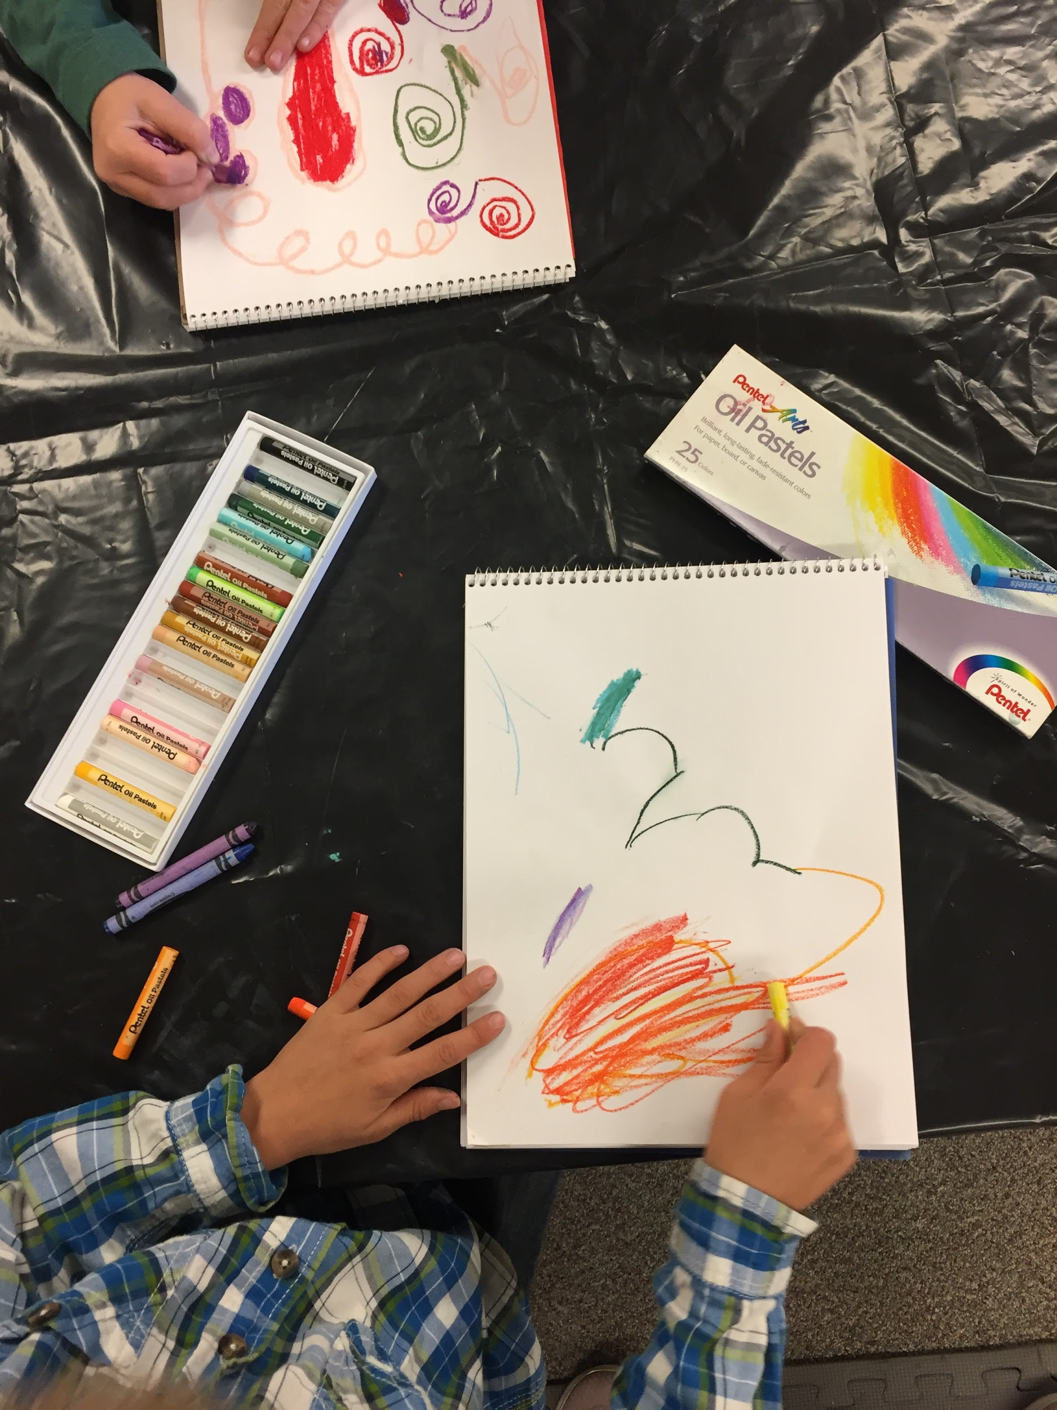
- Observational looking of birds 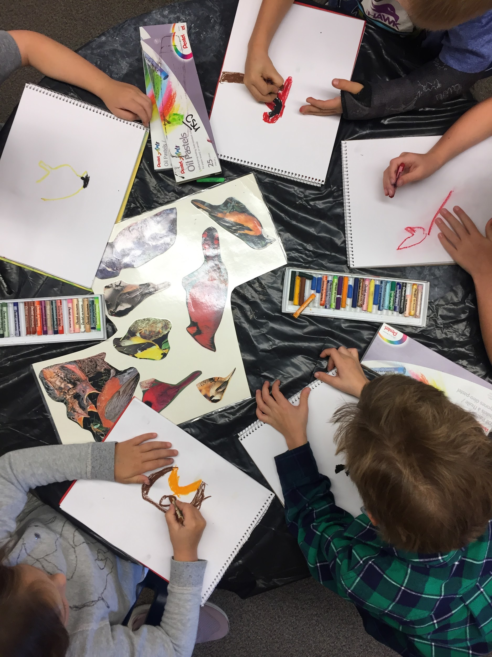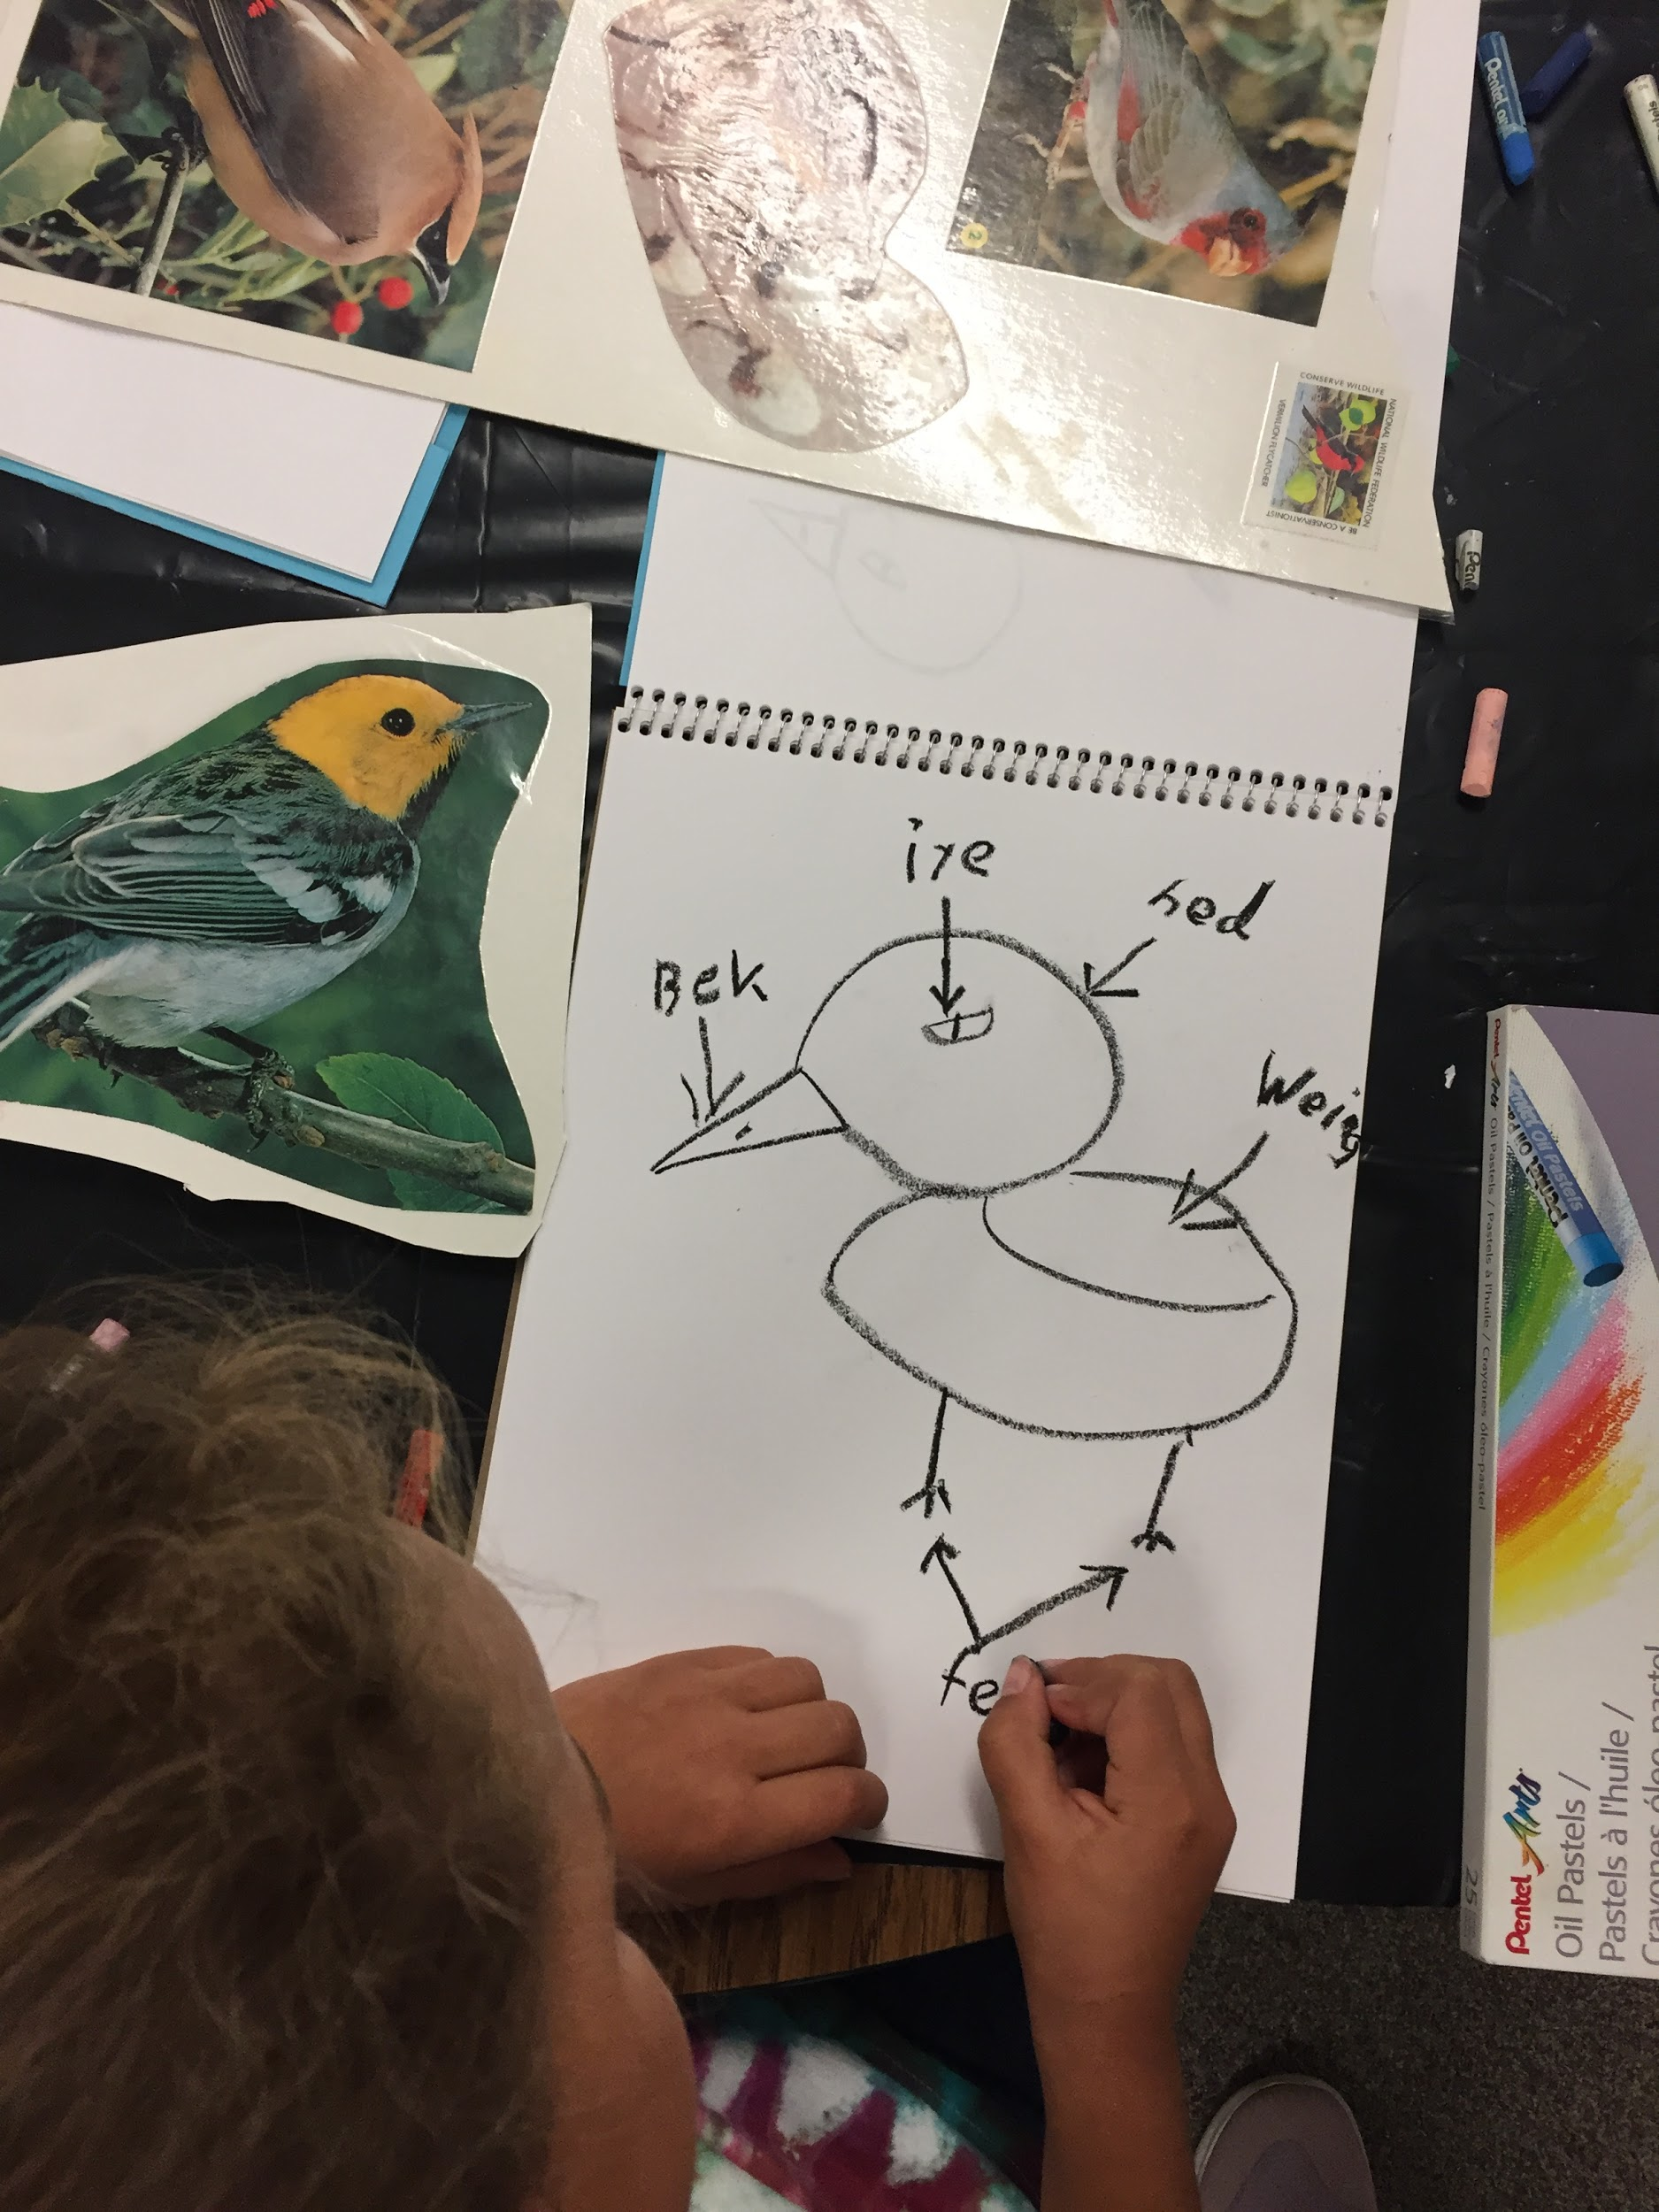

Performance:
What will students accomplish as a result of this lesson? This can be presented to students in the form of a story. In this narrative the students take on a role and create a learning product about a specific topic for a certain audience. (RAFT – Role / Audience / Format / Topic)
Flight of Fancy--Oil Pastel, watercolor, head/body/tail exquisite corpse, observational drawing. Multiple images of birds will be placed at each table. Still drawing from observation, draw the head of one of the birds (switch) draw body with wings (switch) draw tail. Talk about observation, is this still documentation? Why do different birds have different features? Artist Enrique Gomez De Molina

Concepts:
List the big ideas students will be introduced to in the lesson. These ideas are universal, timeless and transferrable. Examples of concepts used in art might include: Composition, Patterns, Technique, Rhythm, Paradox, Influence, Style, Force, Culture, Space/Time/Energy, Line, Law/Rules, Value, Expressions, Emotions, Tradition, Symbol, Movement, Shape, Improvisation, and Observation Look for concepts in the standards, content specific curriculum, etc.
Observation
Imagination
Composition

Enduring Understanding (s):
Enduring Understandings show a relationship between two or more concepts; connected with an active verb. The best enduring understandings not only link two or more concepts; but demonstrate why this relationship is important. Like concepts, they are timeless, transferrable and universal.
Artists can take observations by using composition and line.
Artists can combine observation and imagination to come up with creative solutions.

Standards: (All lessons should address all standards.)
1. Observe and Learn to Comprehend
2. Envision and Critique to Reflect
3. Invent and Discover to Create
4. Relate and Connect to Transfer

Objectives/Outcomes/Learning Targets:
Objectives describe a learning experience with a condition → behavior (measurable) → criterion. Aligned to: Bloom’s – Standards – GLEs - Art learning and, when appropriate, Numeracy, Literacy and Technology. Should be written as: Objective. (Bloom’s: _____ - Standard: _____ - GLE: _____ -Art learning: _____ -Numeracy, Literacy, and/or Technology)
Using last several weeks as review SWBAT relate and remember back to what they had learned through class discussion.
Bloom’s: Understanding
Standard: Transfer
GLE: Visual arts relate experiences to self, family, and friends.
Art learning: aesthetics/transfer
Literacy: Vocab words

Using a variety of birds SWBAT create multiple compositions using inherent characteristics.
Bloom’s: Creating
Standard: Create
GLE: Create art to communicate ideas, feelings, or emotions.
Art learning: Materials/Tools
Literacy

Given artist examples, SWBAT create a plan that uses at least 3 different birds in their drawings.
Bloom’s: Create
Standard: Create
GLE: Assess and produce art with various materials and methods
Art learning: Conceptual-Ideation and Expressive features
Numeracy

Given examples of artwork SWBAT discuss what animals Enrique Gomez De Molina used to created his artwork.
Bloom’s: Analysing
Standard: Comprehend
GLE: Historical and cultural context are found in visual art
Art learning: Historical/multicultural content
Literacy

Given completed work SWBAT evaluate and discuss the characteristics they applied to their new bird.
Bloom’s: Evaluating
Standard: Reflect
GLE: Visual arts provide opportunities to respond to personal works of art and the art of others.
Art Learning: Expressive features and characteristics of art
Literacy

Differentiation:
Explain specifically how you have addressed the needs of exceptional students at both end of the skill and cognitive scale. Describe the strategies you will use for students who are already proficient and need growth beyond what you have planned for the rest of the class, as well as modifications for students with physical and/or cognitive challenges. Students must still meet the objectives.

Differentiation:  (Multiple means for students to access content and multiple modes for student to express understanding.) | Access (Resources and/or Process) | Expression (Products and/or Performance)
 | Posters will be there and we can draw on them shapes so the student may find drawing them easier | Students will be assessed on their interactions with the materials as well as how they express what they intended/created.
Extensions for depth and complexity: | Access (Resources and/or Process) | Expression (Products and/or Performance)
 | Bug jars that are in formaldehyde will be available to look at for more complexity. | Students could do one or two then if they want a challenge pick a bug or a part of a bug that is really complex and focus on one section

Literacy:
List terms (vocabulary) specific to the topic that students will be introduced to in the lesson and describe how literacy is integrated into the lesson.
Review vocab from previous weeks:
inspiration
2-dimensional
3-dimensional
composition
preservation
impression
surveyor

New vocab:
collaboration
scale
Characteristics

Materials:
Must be grade level appropriate. List everything you will need for this lesson, including art supplies and tools. (These are the materials students will use.) List all materials in a bulleted format.
- Paint brushes
- Cups for water
- Tape
- Oil Pastels
- Watercolor
- folded into thirds Mixed media paper

Resources:

List all visual aids and reference material (books, slides, posters, etc. Be specific; include title, artist, etc. Make reference to where the material can be found. (These are the resources used by the teacher to support/develop the lesson.) List all resources in a bulleted format.
- Bird Posters
- Enrique Gomez De Molina
  - https://www.enriquegomezdemolina.com
  - 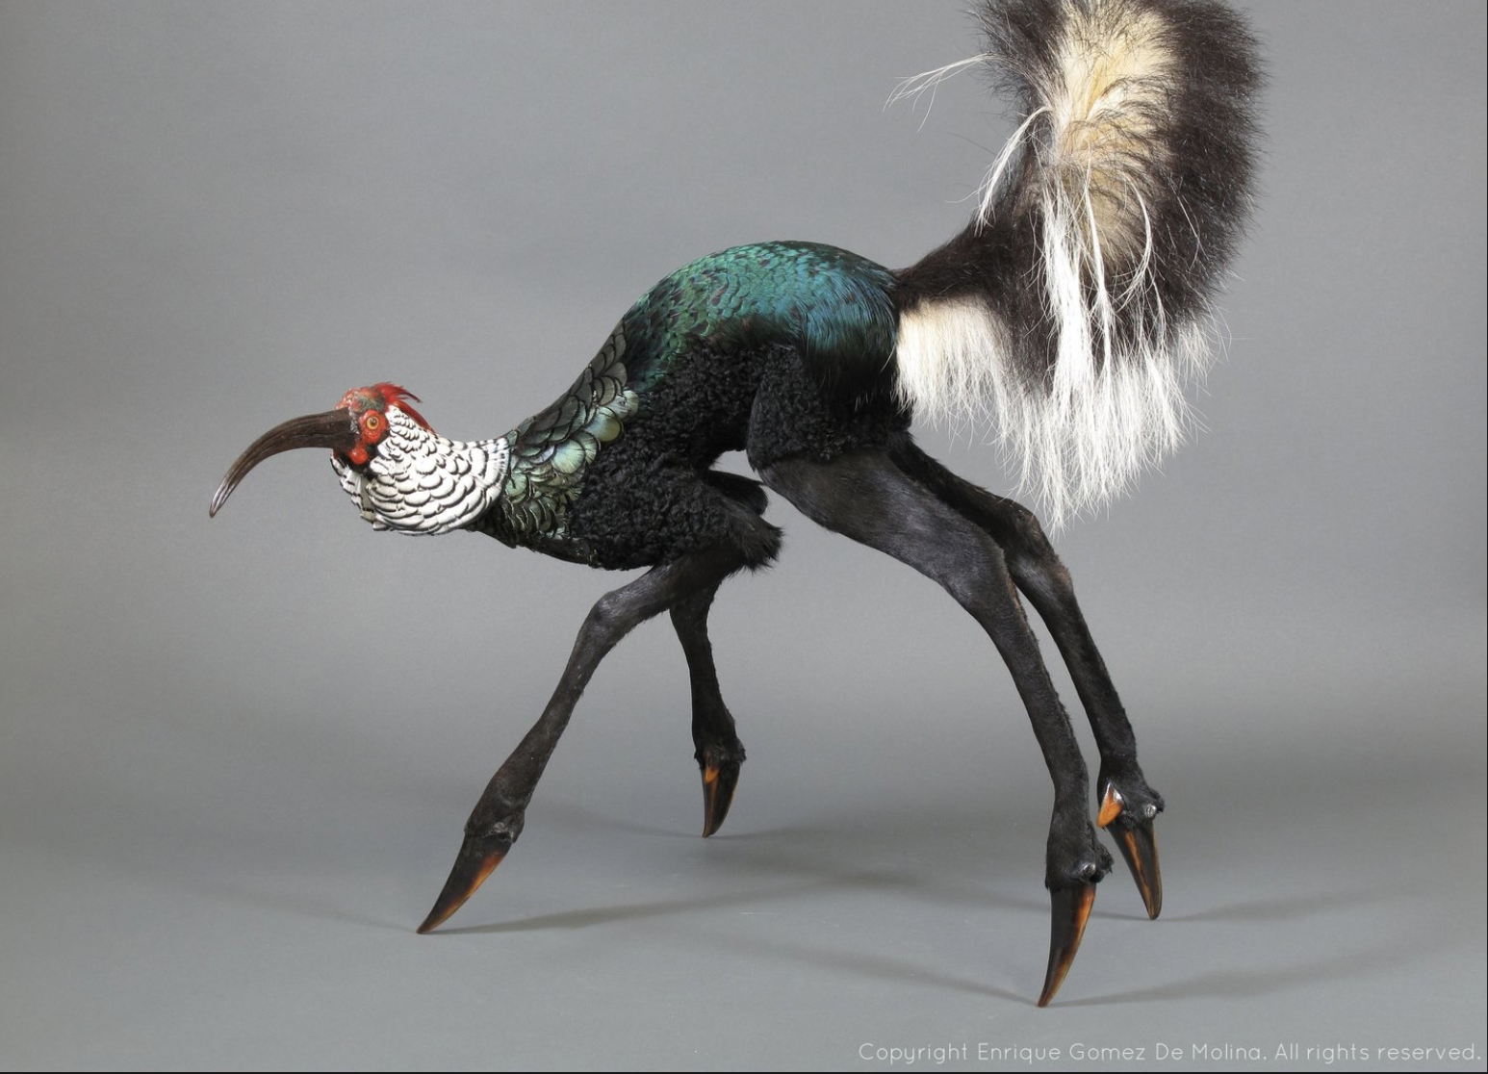
  - 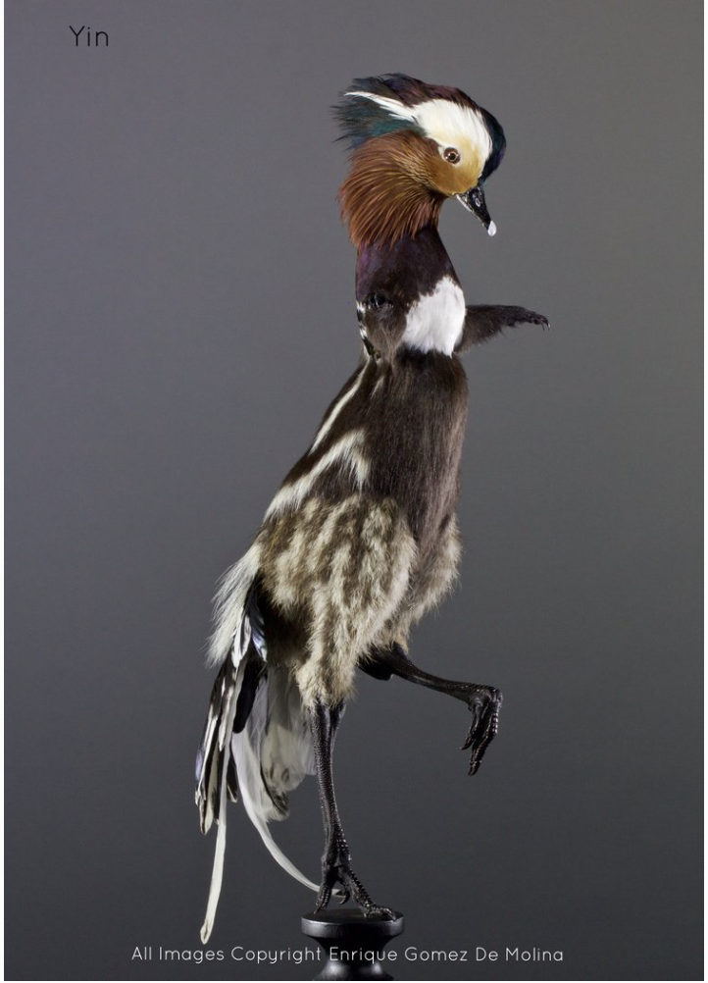
  - 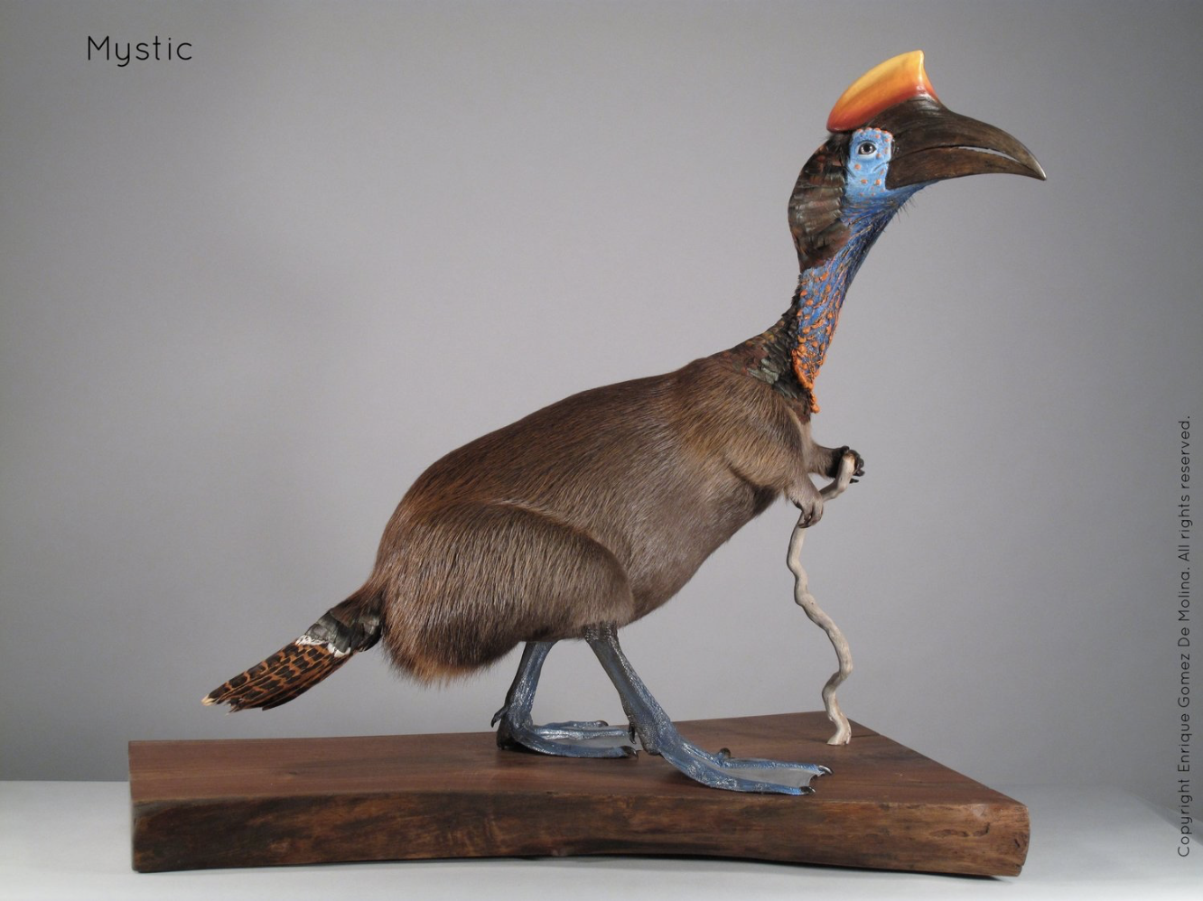

Preparation:
What do you need to prepare for this experience? List steps of preparation in a bulleted format.
- Powerpoint
- Materials

Safety:

Be specific about the safety procedures that need to be addressed with students. List all safety issue in a bulleted format.
No safety concerns

Action to motivate/Inquiry Questions:
Describe how you will begin the lesson to stimulate student’s interest. How will you pique their curiosity and make them interested and excited about the lesson? What inquiry questions will you pose? Be specific about what you will say and do to motivate students and get them thinking and ready to participate. Be aware of the varying range of learning styles/intelligences of your students. Some ideas might include: telling a story, posing a series of questions, role-playing, etc.
Today we are going to be combining our observational skills with some creativity. We will introduce artist slides that demonstrate a great deal of variety, creativity, and exploration. We will be combining different features of birds to compile a new bird of your own creation. Imagine the head of an eagle with the body of a flamingo and the tail of a peacock. Today you get to create a new bird while drawing on your observational skills and using new media-watercolor and oil pastels!

Ideation/Inquiry:
Ideation is the creative process of generating, developing, and communicating new ideas, where an idea is understood as a basic element of thought that can be visual, concrete or abstract. List and describe inquiry questions and processes you will engage students in to help them develop ideas and plans for their artwork.
How many birds do you want to use?
What characteristics of what birds do you want to use?
Do you want your bird to fly?
How are you going to connect these different features of birds in your drawing/painting?
Are you creating your bird to live in a specific environment? Does that bird need special characteristics in order to live there? What birds have those characteristics?

Instruction:
Give a detailed account (in bulleted form) of what you will teach. Be sure to include approximate time for each activity and instructional methodology: skills, lecture, inquiry, etc. Include motivation and ideation/inquiry where appropriate; including what student will understand as a result of the art experience

Day 1 | Instruction - The teacher will... (Be specific about what concepts, information, understandings, etc. will be taught.) Identify instructional methodology. KNOW (Content) and DO (Skill)  8:15-8:30 With students gathered on rug, we will begin class with reflection of last week  -Review blog  -Review word wall  8:30-8:45 Introduce new artists for Flight of Fancy  - Enrique Gomez De Molina  - Questions to be asked:  - If this animal could live somewhere where would it live?  - New Vocab: Characteristic  - What Characteristics give you that idea?  - Have students come up to the board and draw show where the head, body, and tail  8:45-8:55 demonstration: Today we are going to use observational drawing again but we are going to add an element of imagination. We are going to combine at least three different birds to create a new imagined kind of bird. I am going to break my bird into three characteristics: the head, the body, and the tail. Now I can chose a different kind of bird for each characteristic. i.e. the head could be from a penguin, the body from a pelican, and the tail from a turkey.  *paper at student’s seats will be folded into three sections  Step 1: from resources, pick three birds you want to draw  Step 2: begin drawing them with oil pastel  Step 3: switch to watercolor when you are ready and finish birds  - Ideation Questions to be asked:  - How many birds do you want to use?  - Do you want your bird to fly? Some birds don’t fly.  - How are you going to connect the different features of different birds in your drawing/painting?  - Are you creating your bird to live in a specific environment? Does that bird need special characteristics in order to live there? What birds have those characteristics?  8:55-9:10 students work on drawings/paintings  9:10-9:15 students will turn and talk to partner for peer feedback. Some questions for peer feedback can be:  - What is one element of your partner’s bird that they are doing well?  - What is one element they could improve on?  - How are they using color and composition?  - Are they looking observationally and thinking creatively?  9:15-9:25 students will work on drawings/painting  9:25-9:30 clean-up | Learning - Students will... i.e.: explore ideation by making connections,  comparing, contrasting; synthesize possibilities for each painting technique; etc. (Be specific about what will be the intended result of the instruction as it relates to learning.) UNDERSTAND  - thinking precisely about thinking: using critical vocabulary  - listening critically  - questioning deeply: raising and pursuing root or significant questions  - examining or evaluating assumptions  - analyzing or evaluating arguments, interpretations  - listening critically  - questioning deeply: raising and pursuing root or significant questions  - examining or evaluating assumptions  - analyzing or evaluating arguments, interpretations  - listening critically  - examining or evaluating assumptions | Time
Day 2  (catch up day) | 8:15-8:40 Good morning Students!  With students gathered on rug, we will begin class with reflection of all that we have done so far in art.  -Review blog  - ask what materials were used in each lesson  -- Halloween Jumping Jack O'lanterns  -Review word wall  8:30-8:45  Demo of painting for tiles  Take test tiles and use paint (that we still need to discuss and figure out)  Demo: Today we are going to add color to our tiles that we IMPRESSED into. Ask the students what materials we used to make our birds. Students will take what they learned from Flight of fancy and apply it to their tiles.  Teaching points to remind the students:  - Tiles are fragile! Make sure you handle very gently!  - More water makes the color lighter, Less water makes the color darker.  - Oil Pastels resist watercolor. So anywhere you put oil pastel the watercolor won’t be there.  - Ask them to think about if they want to add color to the back of the work.  Give students time to work then have a pause moment. Bring back to rug walk as spider.  Show the students what they could be doing after they finish their tiles. As well write it on a piece of paper so they can look at it when they are done.  - Paste their bugs into their sketchbook  - Finish Flight of fancy birds  - Cover of Sketchbook  - Draw in sketchbook  - try new materials to draw with  8:45-9:15  Choice based Catch Up activities  Paint tiles  - Oil Pastel  - Watercolors  Flight of fancy birds  - Oil Pastels  - Water Colors  Place Bugs in Sketchbook  - Glue  Work on cover of Sketchbook  - Oil Pastels  Sketchbook  If done with everything else.  - oil pastels  - color pencils  - Water color pencils?  9:15-9:30  Clean up by table groups  Orange group - Color pencils, oil pastels  Red group - Water, Water Colors  Yellow group - Paint, bird posters  Green group - Clean up floor, Extra oil pastels | - thinking precisely about thinking: using critical vocabulary  - listening critically  - examining or evaluating assumptions  - analyzing or evaluating arguments, interpretations

Student reflective/inquiry activity:
Sample questions and activities (i.e. games, gallery walk, artist statement, interview) intended to promote deeper thinking, reflection and refined understandings precisely related to the grade level expectations. How will students reflect on their learning? A participatory activity that includes students in finding meaning, inquiring about materials and techniques and reflecting about their experience as it relates to objectives, standards and grade level expectations of the lesson.)
Students will reflect on bugs in a jar via our class jar. Students will discuss shift of scale, composition, and the effects of working collaboratively.
Students will turn and talk to partner for in-progress peer feedback for in flight of fancy.

Post-Assessment (teacher-centered/objectives as questions):  Have students achieved the objectives and grade level expectations specified in your lesson plan? | Post-Assessment Instrument:  How well have students achieved the objectives and grade level expectations specified in your lesson plan? Include your rubric, checklist, rating scale, etc.
Can students compare and contrast the individual vs. group by class discussion?  Can students relate and remember back to what they had learned through class discussion?  Can students create multiple compositions using inherent characteristics?  Can students create a plan that uses at least 3 different birds in their drawings?  Can students discuss what animals Enrique Gomez De Molina used created his work? | - compare and contrast the individual vs. group by class discussion  - relate and remember back to what they had learned through class discussion  - create multiple compositions using inherent characteristics  - create a plan that uses at least 3 different birds in their drawings  - discuss what animals Enrique Gomez De Molina used created his work  ++ Very Well  + Proficient  / Developing

Self-Reflection:
After the lesson is concluded write a brief reflection of what went well, what surprised you, and what you would do differently. Specifically address: (1) To what extent were lesson objectives achieved? (Utilize assessment data to justify your level of achievement.) (2) What changes, omissions, or additions to the lesson would you make if you were to teach again? (3)What do you envision for the next lesson? (Continued practice, reteach content, etc.)
Clarissa Brobst
Class 5
10/17/17

What went well?
I think Katie and I are a good team and so we feed off each other. So that works really well in our favor and as well for the students. The motivation PowerPoint got the students super excited. They got to come up to the smart board and draw on it and point out the animals they saw. They also debated with each other. This was super important for the new lesson. In order to help move the students from bugs to birds.

What didn’t go well?
I know that it’s easier for me to think about the things that didn’t go well after the thought. And some are being pointed out to me. For instance 2 of our students only drew one bird. Katie told them 2 and had them repeat the instruction of 2 different bird parts. One of the students has trouble with color and really only works in black and white. His victory was adding orange without being told to. But I question if I should have tried harder for both students in getting them out of their comfort zone. Would this have made a difference for our next lesson? And the answer is most likely yes. I just wish I knew how to do it. How to help guide them to take it one step further.

What will I do differently?
Try harder in getting the two students to step outside the box. Even if it meant sitting down with them and working one on one with them.

Katie Mills
What went well:
We really allowed quite a bit of time for this project. Students were given nearly all of class to work on their bird compilation. Because we had time, we allowed students to practice in their sketchbook. It was really nice to see the work they were doing in there. It was also nice to see how that translated to their final project. We also did two turn-and-talks for peer feedback and I think this helped students develop their work and get more polished final project. It was fun to see some things that happened organically-like the students naming their birds. I'm pretty sure that was started by one student but it quickly caught on to the entire room. It was also a pleasant surprise during our group talk to hear students say things like "my bird is a carnivore and lives in the desert." Some of the questions Clarissa and I were asking them was "Where might your bird live?" and "Why did you choose certain characteristics for your bird?" So it was nice to see them considering these in their process. These considerations will tie into our final project with them.
What didn't go well:
I wish I would have reminded students to draw bigger. Many students made their birds really small and when the went to watercolor them there just wasn't as much room to explore. This was also one of the first classes where we almost didn't have enough for them to do. Thankfully, we decided to have them do sketches in their sketchbook and I think this was worth while but I would love to come up with some more authentic supplemental prompts and/or activities so that our super fast students still are getting something meaningful out of class. For their project, students were asked to combine characteristics from at least two birds (more if they wanted) to create a new bird but two students just drew a single bird exactly as it was. Both Clarissa and I prompted both of these students to mash up different characteristics but both students were resistant. I personally gave up this battle because they were producing quality work and drawing from observation. I think those students missed out on an opportunity to use their imagination and get creative but I know our final project will ask a lot of them in that sense so I will definitely be proactive about getting them engaged then.
What I would do differently:
I would have come to class with more supplemental work for students that finish early. I would reminded students to draw big. I think most of us (teachers) have a great advantage of working as a team teach right now and moving forward I just want to be sure that since there are two of us and eighteen kids, that I am really checking in with each student. Like I said, with the numbers this is easier to do and I really want to find ways to motivate and enable those two students who couldn't push themselves to create a new bird. In two weeks (because we don't have class this week) Clarissa and I will be running a bit of a catch up day and the craziness of everyone working on different stuff, I want to be sure that I'm remembering to check in with my students one-on-one.

Clarissa Brobst
Class 6
10/28/17

What went well?
Many things went well during class. This was one of the classes that was more controlled hectic. There was a lot going on and students were doing many things. But the student handled it very well. I also think that they enjoyed revisiting what we did before. We also had a student that was trying to use scissors unsafely. She was trying to cut in the air as well as cut the clay that had already been fired. She was testing me and Katie. And we told her she was being unsafe and she needs to put this scissors away. I told her twice and she slowly made her way to put them away. Denise was just mouthing to take them from her and that would have been my next move but I was willing to give her that chance.
What didn’t go well?
I don’t really think anything when bad. The only thing that was hard for some students was cutting out their bird. And that may have taken them more time than they thought it would so that have held up some of them from finishing all the tasks for the day.
What will I do differently?
I would make sure that we added in that pre-assessment. We had it in the lesson plan but we had so much for them to do that time just ran out. So we don’t have an idea on how they are going to do this but they are creative. I think something that I would also do better would be to re-order what the students did. It wasn’t bad but not all students got to put their bugs in their sketchbook.

Appendix: Include all handouts, prompts, written materials, rubrics, etc. that will be given to students.

8/9/15 Fahey

