Lesson Plan Title: Creatures in Space Length: 3 Classes

Note: Before you plan and write art experiences; pre-assess your students based on the proposed concepts, enduring understandings, and objectives of the unit/lesson(s). You may also gather this information from (previous) teachers, by reviewing already completed art work, consulting curriculum materials, etc., to get a better understanding of what content students already know and what they will need to know to be successful.

Pre-Assessment:
This will need to be done prior to teaching your lesson. Outline the method you will use to determine the skill/knowledge level of your students based on the concepts/enduring understandings/objectives of the lesson. (Hint: turn these into questions.) Be specific in describing what you would recognize as proficient skill/knowledge.
Painting frenzy ( see instructions)

Performance:
What will students accomplish as a result of this lesson? This can be presented to students in the form of a story. In this narrative the students take on a role and create a learning product about a specific topic for a certain audience. (RAFT – Role / Audience / Format / Topic)
You are a well known artist. And you have been asked to make a display in a big natural history museum in New York. They have asked of you to show ONE or TWO preliminary sketches for the environment AND your creature. They ask that your creature be 3D and your environment 2D. Then later you will be taking a few of your classmates on a special preview of your creature in space! Where you will be discussing your choices you made in you work of art. You’ll almost be a tour guide!

Concepts:
List the big ideas students will be introduced to in the lesson. These ideas are universal, timeless and transferrable. Examples of concepts used in art might include: Composition, Patterns, Technique, Rhythm, Paradox, Influence, Style, Force, Culture, Space/Time/Energy, Line, Law/Rules, Value, Expressions, Emotions, Tradition, Symbol, Movement, Shape, Improvisation, and Observation Look for concepts in the standards, content specific curriculum, etc.
Design
Planning
Reflect and Respond
Imagination
Explore

Enduring Understanding (s):
Enduring Understandings show a relationship between two or more concepts; connected with an active verb. The best enduring understandings not only link two or more concepts; but demonstrate why this relationship is important. Like concepts, they are timeless, transferrable and universal.
Artist and designers use their imagination to design 2D, 3D objects.
Artist and designers explore and then reflect and or respond to their artwork.

Standards: (All lessons should address all standards.)
1. Observe and Learn to Comprehend
2. Envision and Critique to Reflect
3. Invent and Discover to Create
4. Relate and Connect to Transfer

Objectives/Outcomes/Learning Targets:
Objectives describe a learning experience with a condition → behavior (measurable) → criterion. Aligned to: Bloom’s – Standards – GLEs - Art learning and, when appropriate, Numeracy, Literacy and Technology. Should be written as: Objective. (Bloom’s: _____ - Standard: _____ - GLE: _____ -Art learning: _____ -Numeracy, Literacy, and/or Technology)
Using last several weeks as review SWBAT relate and remember back to what they had learned from previous instruction through class discussion.
Bloom’s: Understanding
Standard: Transfer
GLE: Visual arts relate experiences to self, family, and friends.
Art learning: aesthetics/transfer
Literacy: Vocab words

Given artist examples, SWBAT compose a plan to build a Three-Dimensional sculpture and a Two-Dimensional backdrop in their sketchbook 1-2 sketches or plans.
Bloom’s: Create
Standard: Create
GLE: Create art to communicate ideas, feelings, or emotions.
Art learning: Conceptual-Ideation and Expressive features

Given examples of artwork SWBAT discuss how the main object is in a different environment than it should be from contemporary artist such as Makoto Azuma.
Bloom’s: Analysing
Standard: Comprehend
GLE: Historical and cultural context are found in visual art
Art learning: Historical/multicultural content
Given art materials SWBAT design the 3D and 2D objects using materials experimentally.
Blooms: Create
Standard: Create
GLE: Create art to communicate ideas, feelings, or emotions.
Art Learning: Materials and Tools/ Techniques

Using completed/incomplete artwork, SWBAT discuss their relationship between their 2D and 3D objects.
Bloom’s: Evaluate
Standard: Transfer and Reflect
GLE: Visual arts relate experiences to self, family, and friends.
Art learning: Assessment-Evaluation
Literacy

Differentiation:
Explain specifically how you have addressed the needs of exceptional students at both end of the skill and cognitive scale. Describe the strategies you will use for students who are already proficient and need growth beyond what you have planned for the rest of the class, as well as modifications for students with physical and/or cognitive challenges. Students must still meet the objectives.

Differentiation:  (Multiple means for students to access content and multiple modes for student to express understanding.) | Access (Resources and/or Process) | Expression (Products and/or Performance)
 | Draw with pencils before they paint. | If needed they can talk one on one about their work with me or Katie.
Extensions for depth and complexity: | Access (Resources and/or Process) | Expression (Products and/or Performance)
 | Cut out objects to fit in their space. Such as buildings and or trees.  Use armature for creature | Students can record themselves in expressing how they made their work.  Achieve different form for their creature

Literacy:
List terms (vocabulary) specific to the topic that students will be introduced to in the lesson and describe how literacy is integrated into the lesson.
- Vocab Words
  - Creatures
  - Environment
- Turn and talk feedback ( DAY ONE)
- Give your peer one grow and one glow about their background “space” sketch. What is one thing they did well? What is one thing they could work on? Can you tell WHERE their space is without them telling you? Have they included details in their space? Are there plants, buildings, sky, water?
- Once done with sketches come show Katie or Clarissa. (DAY TWO)
  - Ask questions such as.
    - What materials do you plan on using?
    - How do you plan on building it?
    - How does your creature fit into your background?

Materials:
Must be grade level appropriate. List everything you will need for this lesson, including art supplies and tools. (These are the materials students will use.) List all materials in a bulleted format.
DAY ONE
Paper
- Paint play paper
- White
- Black
- Colored
Paints
- Colored Acrylic
- Material Acrylic
3D objects
- Feathers
- Beads
- Other objects that they can build with
DAY 2/3
Paper
- White
- Black
- Colored
Paints
- Colored Acrylic
- Material Acrylic
3D objects
- Feathers
- Beads
- Other objects that they can build with
- air dry clay
- card board

Resources:

List all visual aids and reference material (books, slides, posters, etc. Be specific; include title, artist, etc. Make reference to where the material can be found. (These are the resources used by the teacher to support/develop the lesson.) List all resources in a bulleted format.
PowerPoint of Images
- Makoto Azuma

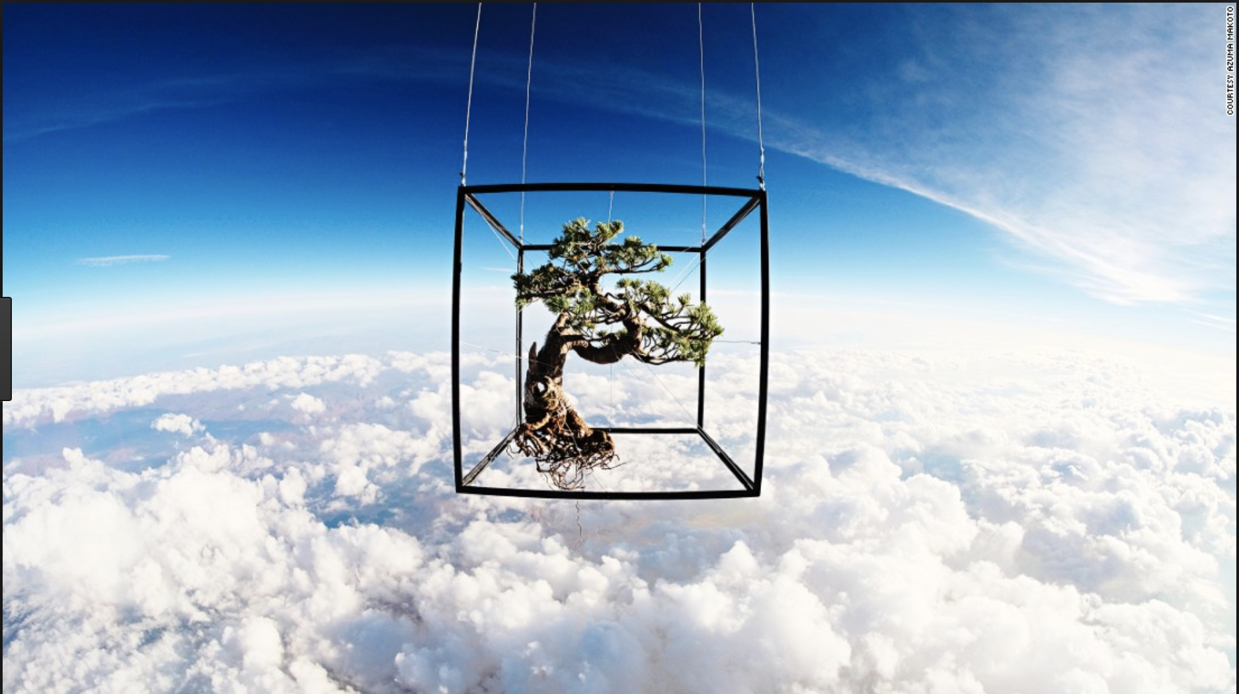

Natural History Museums:
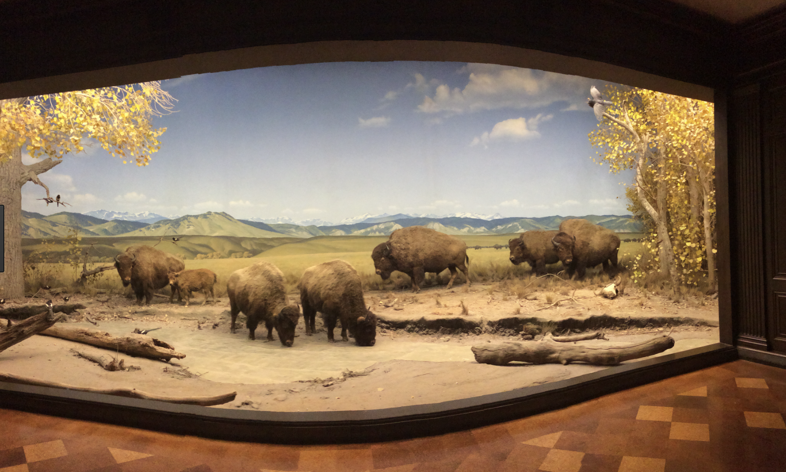http://coyotechronicle.net/wp-content/uploads/2014/05/IMG_1944.jpg

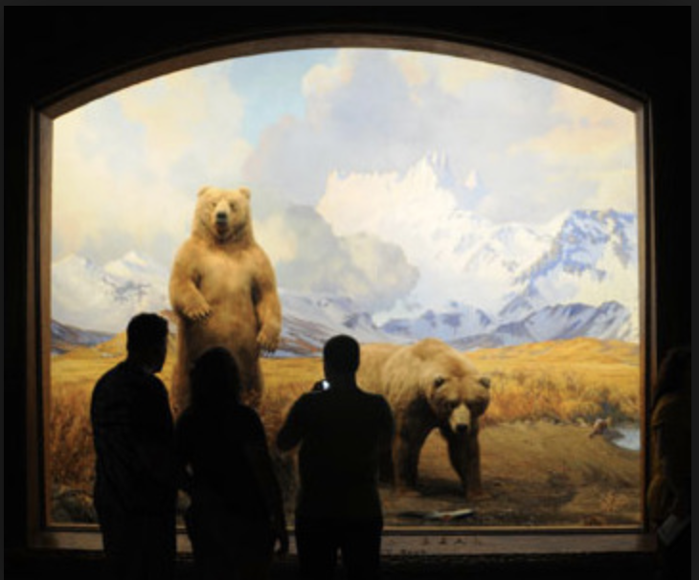https://i.pinimg.com/originals/6d/7e/be/6d7ebe8e22fcf1526453847a25441fbe.jpg

Preparation:
What do you need to prepare for this experience? List steps of preparation in a bulleted format.
Powerpoint
Gather Materials of resources for ideation and inquiry
Ideation paper

Safety:

Be specific about the safety procedures that need to be addressed with students. List all safety issue in a bulleted format.
There are no safety concerns.

Action to motivate/Inquiry Questions:
Describe how you will begin the lesson to stimulate student’s interest. How will you pique their curiosity and make them interested and excited about the lesson? What inquiry questions will you pose? Be specific about what you will say and do to motivate students and get them thinking and ready to participate. Be aware of the varying range of learning styles/intelligences of your students. Some ideas might include: telling a story, posing a series of questions, role-playing, etc.
Free paint frenzy! Find where your sketchbook is located and take a seat. For the next few minutes you are going to experiment with acrylic paint in your sketchbook. You can paint whatever you want in this time. If you’re not sure where to begin, you can consider these questions:
-What happens when you mix colors?
-What different marks can you get with your paintbrush?
-What composition do you want to have?

Makoto Azuma

Ideation/Inquiry:
Ideation is the creative process of generating, developing, and communicating new ideas, where an idea is understood as a basic element of thought that can be visual, concrete or abstract. List and describe inquiry questions and processes you will engage students in to help them develop ideas and plans for their artwork.
Ideation: Written on white board, discussed as a class
Could you give some examples of different environments?

Instruction:
Give a detailed account (in bulleted form) of what you will teach. Be sure to include approximate time for each activity and instructional methodology: skills, lecture, inquiry, etc. Include motivation and ideation/inquiry where appropriate; including what student will understand as a result of the art experience

Day 1 | Instruction - The teacher will... (Be specific about what concepts, information, understandings, etc. will be taught.) Identify instructional methodology. KNOW (Content) and DO (Skill)  8:15-8:25 Free paint frenzy! Find a seat, on the paper in front of you write your name and then flip it over and begin painting. For the next few minutes you are going to experiment with acrylic paint in your sketchbook. You can paint whatever you want in this time. If you’re not sure where to begin, you can consider these questions:  -What happens when you mix colors?  -What different marks can you get with your paintbrush?  -What composition do you want to have?  8:25-8:30 With students gathered on rug, we will begin class with reflection of last week  -Review blog  -Review word wall-introduce new word today “environment”  -Introduce this week’s artists  -JUMPING JACKS  -Natural history museums  8:30-8:40  Today we are going to be starting a project called “creatures in space”. For this project we are going to be creating three-dimensional creatures that will be placed in front of two-dimensional backgrounds as if they were dioramas on display in a museum. So you will be creating both the creature and an environment for them. Today, we will be starting with our background (the space). We will be starting in our sketchbooks. But before we do we’re going to be a bit of brainstorming first. I will be writing down your ideas as you shout them.  -Could you give me some examples of environments you could put your creature in?  -Could it be inside? Outside? Underground? In the sky? On Earth? On another planet?  (after list is made)  Ok, now let’s pretend my background has mountains, blue skies, fields, and a river. My creature might be able to both swim (in the river) and fly. Maybe my creature is a carnivore and eats field mice in this environment and so I’d give it claws. See how I am considering characteristics of my creature as I work on my background? Now we won’t be working on our creatures until next week but you should be thinking about your creature as you make the background!  Now that we have some ideas for our spaces, you will sketch a “space” on a clean piece of paper in your sketchbook using pencil and/or colored pencil. This is just a first shot. Consider: What is in your space? We will move on to the final draft in a minute.  Demo  This is what a preliminary sketch should look like. I am considering what I want to have in my space. My space is underwater and I am showing that by drawing plants you would see underwater and by showing waves at the top of my page. I used colored pencil but you don’t have to.  8:40-8:50 Preliminary sketch time  In sketchbook with pencil and/or colored pencil students will do a preliminary sketch of their “space” (aka background for their creature) in their sketchbook.  8:50-9:00 Turn and talk feedback  Give your peer one grow and one glow about their background “space” sketch. What is one thing they did well? What is one thing they could work on? Can you tell WHERE their space is without them telling you? Have they included details in their space? Are there plants, buildings, sky, water?  9:00-9:20 Move on to final  Now students will be moving on to their big paper final draft. On this paper students will use acrylic paint to depict their space. There will be a couple plates of paint on each table as well as brushes and water.  9:20-9:30 Clean up  -collect sketchbooks  -clean and collect brushes  -throw paper plates of paint away  -collect backgrounds | Learning - Students will... i.e.: explore ideation by making connections,  comparing, contrasting; synthesize possibilities for each painting technique; etc. (Be specific about what will be the intended result of the instruction as it relates to learning.) UNDERSTAND  - examining or evaluating assumptions  - analyzing or evaluating arguments, interpretations  - thinking precisely about thinking: using critical vocabulary  - listening critically  - listening critically  - questioning deeply: raising and pursuing root or significant questions  - examining or evaluating assumptions  - analyzing or evaluating arguments, interpretations  - listening critically  - questioning deeply: raising and pursuing root or significant questions  - examining or evaluating assumptions  - analyzing or evaluating arguments, interpretations | Time
Day 2 | Good Morning Artists!  8:20-8:30 With students gathered on rug, we will begin class with reflection of last week  -Review blog  -Review word wall  -Review what our RAFT was and what the task at hand is  “You are a well known artist. And you have been asked to make a display in a big natural history museum in New York. They have asked of you to show ONE or TWO preliminary sketches for the environment AND your creature. They ask that your creature be 3D and your environment 2D. Then later you will be taking a few of your classmates on a special preview of your creature in space! Where you will be discussing your choices you made in you work of art. You’ll almost be a tour guide!”  -JUMPING JACKS  8:30- 8:55 Finish 2D paintings  8:55-9:05  - Bring students back to rug and introduce the 3D creature.  What is a creature? Can it be real? Can it not be real? Should it fit into your background? Write down what the class comes up with.  Have a few buckets/pans in the front of class where students that are done with paintings can come up and look at the materials and see what they might want to use. After they have looked for a while they are going to use this information to help them sketch 1 or 2 drawings of their creatures.  If they are done with 2D drawings place on drying rack  9:05 - 9:23  Once done with sketches come show Katie or Clarissa.  Ask questions such as.  What materials do you plan on using?  How do you plan on building it?  How does your creature fit into your background?  9:23- 9:30  Clean up --Written on white board  Everyone Sketchbook put away  Leave painting or creature at table  Green group -- paints bring to clarissa  Red group -- paint brushes  Orange group -- pencils  Yellow group -- water bowls | - thinking precisely about thinking: using critical vocabulary  - listening critically  - listening critically  - questioning deeply: raising and pursuing root or significant questions  - examining or evaluating assumptions  - analyzing or evaluating arguments, interpretations  - questioning deeply: raising and pursuing root or significant questions  - examining or evaluating assumptions  - analyzing or evaluating arguments, interpretations
Day 3 | Welcome Students!!  8:20-8:30 With students gathered on rug, we will begin class with reflection of last few weeks  -Review blog  -Review word wall  -Review what our RAFT was and what the task at hand is  “You are a well known artist. And you have been asked to make a display in a big natural history museum in New York. They have asked of you to show ONE or TWO preliminary sketches for the environment AND your creature. They ask that your creature be 3D and your environment 2D. Then later you will be taking a few of your classmates on a special preview of your creature in space! Where you will be discussing your choices you made in you work of art. You’ll almost be a tour guide!”  Remember to tell the students that this is their last work day. Tour Guide will happen during next time we see you.  STAR JUMPS  8:30- 8:43  Students will grab their sketchbooks. And open them up.  Students please open to your drawn sketches of your environment and your creature.  Partner talk:  What do you remember about the characteristics of your creature that made your creature fit into your environment?  8:43 - 9:15  Work on 3D creatures.  Painting of creatures  If student says they are done ask them to ask someone else next to them for “peer feedback”  - Something they like and why  - Something they could work on  If the students finish.  Differentiation:  Cut out objects to fit in their space. Such as buildings and or trees.  9:15 - 9:30  Clean up --Written on white board  Everyone Sketchbook put away  Place creature in bag  Green group -- paints bring to clarissa  Red group -- paint brushes  Orange group -- pencils  Yellow group -- water bowls  Everyone- Floor scraps, scissors ect. | - thinking precisely about thinking: using critical vocabulary  - listening critically  - questioning deeply: raising and pursuing root or significant questions  - questioning deeply: raising and pursuing root or significant questions  - examining or evaluating assumptions  - analyzing or evaluating arguments, interpretations
Day 4 | Welcome Students  8:20-8:30  Your artwork is all set up. All of the work you made over this semester.  Remind students about tour guide.  “You are a well known artist. And you have been asked to make a display in a big natural history museum in New York. They have asked of you to show ONE or TWO preliminary sketches for the environment AND your creature. They ask that your creature be 3D and your environment 2D. Then later you will be taking a few of your classmates on a special preview of your creature in space! Where you will be discussing your choices you made in you work of art. You’ll almost be a tour guide!”  We want you to think of what you did.  ( this will be written on a board in the multipurpose room for the students too look back at incase they forget. )  ONLY START WITH YOUR CREATURES we will look at everything else after. Everyone will be in the multipurpose room so let us come up with a sign or a code that says meet back with me and Katie.  Come up with class sign/code.  So back to your creatures  We want you to talk about  - The name of your creature  - What environment it is in  - What is its name  - And anything else you would like to speak on  Group will be  1  - Forest  - Hayden  - Arwyn  - Grey  2  - Jasper  - Traian  - Charli  - Jaida  3  - Oliver  - Zoey  - Louisa  - Cedar  - Wynn  4  - Jude  - Delia  - Maggie  - Odin  - Nyima  Practice code before leaving the room.  8:30 - 8:50ish (or when they are done)  “Tour”  8:50ish (or when they are done) - 9:10  Students will get a chance to look at everyone else work.  K-5.  Code will be said  We will gather together.  Then students will talk and show to a partner about  - talk about what they saw  - something they found interesting  - show something they would take home if they could that's not their artwork and why  9:10 -9:25  Sponge activity  Scratch Art- students will enjoy one last activity of creating scratch art.  - They can choose to draw what they want  - Another bug (bring in a few posters)  - Or Their creature  9:25-9:30  Clean up - place scratch art in backpack

Student reflective/inquiry activity:
Sample questions and activities (i.e. games, gallery walk, artist statement, interview) intended to promote deeper thinking, reflection and refined understandings precisely related to the grade level expectations. How will students reflect on their learning? A participatory activity that includes students in finding meaning, inquiring about materials and techniques and reflecting about their experience as it relates to objectives, standards and grade level expectations of the lesson.)
Students will be grouped into new groups (number off 1-4) in new groups students will present their creature and environment to their other group members. There will be a box in the center of the table and students will tape their backgrounds to the four sides of their box. Students will be “museum guides” and walk their peers thought their exhibit. They will talk about characteristics of their background and their creature and the relationship between the two.

Post-Assessment (teacher-centered/objectives as questions):  Have students achieved the objectives and grade level expectations specified in your lesson plan? | Post-Assessment Instrument:  How well have students achieved the objectives and grade level expectations specified in your lesson plan? Include your rubric, checklist, rating scale, etc.
Can students relate and remember back to what they had learned from previous instruction through class instruction?  Can students compose a plan to build a 3D sculpture and 2D backdrop in their sketchbook with 1-2 sketches/plans?  Can students discuss how the main object is in a different environment than it should be in examples of artwork?  Can students design the 3D and 2D objects using materials experimentally?  Can students discuss their relationship between their 2D and 3D objects? | - relate and remember back to what they had learned from previous instruction through class instruction  - plan to build a 3D sculpture and 2D backdrop in their sketchbook with 1-2 sketches/plans  - discuss how the main object is in a different environment than it should be in examples of artwork  - design the 3D and 2D objects using materials experimentally  - discuss their relationship between their 2D and 3D objects  ++ Very Well  + Proficient  / Developing  ++ Very Well  - Can relate and remember everything from what they have learned all semester long  - planned 3-4 sketches or plans of the 3D and 2D  - Discuss extremely well about how the main object is or isn't in a different environment than it should be  - used many materials experimentally  - discuss extremely well about the relationship between their 2D and 3D objects  + Proficient  - Can relate and remember a lot from what they have learned all semester long  - planned 1-2 sketches or plans of the 3D and 2D  - Discuss well about how the main object is or isn't in a different environment than it should be  - used some materials experimentally  - discuss well about the relationship between their 2D and 3D objects  / Developing  - Can relate and remember some from what they have learned all semester long  - planned 1-0 sketches or plans of the 3D and 2D  - Discuss somewhat about how the main object is or isn't in a different environment than it should be  - used little to none materials experimentally  - discuss somewhat about the relationship between their 2D and 3D objects

Self-Reflection:
After the lesson is concluded write a brief reflection of what went well, what surprised you, and what you would do differently. Specifically address: (1) To what extent were lesson objectives achieved? (Utilize assessment data to justify your level of achievement.) (2) What changes, omissions, or additions to the lesson would you make if you were to teach again? (3)What do you envision for the next lesson? (Continued practice, reteach content, etc.)

Katie Mills

What went well
This week we explored the backgrounds or "environments" for our creatures in space project. We added "environment" to our word wall and reflected on our vocab so far this semester and these connections are becoming really solid. We brainstormed what different environments could be. This was meaningful because some students thought environment as very binary i.e. desert, jungle, mountains but then when brainstorming we realized environment can include Fort Collins, our classroom, underwater, etc. Through brainstorming I think we also tapped in to some excitement for the project. As we started to list all the things that could be included in environment students engaged with an idea they were passionate about.
What didn't go well
It's not that this is necessarily bad, but students spent longer on this aspect than we thought they would. I was happy about this because their ideas seemed developed and they seem invested in their work. But I'm anxious about this because we allotted three class periods for "creatures in space". This first class was meant for the environments, the second for their creatures, and the third was the reflection for the project. As it is, we are going to use next class to finish environments and get started on creatures and then finish creatures on the third day and go directly into reflection and I think this will be an ok solution. We are trying to spend a longer amount of time on our reflection because it is more in-depth, requiring students to step into a role as a museum tour guide and take their peers on a tour of their creature in space; I think so long as we have a minimum of 20 minutes for this, we can still achieve it. Clean up could have gone a little bit better. Denise pointed out that we could have been more specific. Also, just throughout class, the tables got cluttered because we were working on so much and I saw one altercation were a student snapped at their table because their work was crowded. I had students move some of their stuff to the floor but I know this wasn't the best solution. I think we also could have had some more examples of artist work concerning our topic to better explain what we were asking of the students.
What I would do differently
We've already made some time adjustments to our unit. As for the cluttered table space, next time, I would have students clean up after our pre-assessment "painting frenzy". Students would bring their paintings to one table to dry. THEN we would move on to our sketches with relatively clean tables. After students were finished sketching on their final draft for their environment, their sketchbooks could be but back in the basket so (again) they had nice, clean table space. Next time I do this project, I would be sure to specifically seek out artists that make art specific to environment. As it is, Clarissa and I found great examples of artists' work that take an object and place it in an environment in which it doesn't belong but we don't have an example in which the environment and object work together. We told students they could choose either relationship between their creature and environment. i.e. They could create a background for their creature OR they could come up with a totally wacky background in which their creature didn't belong.

Katie Mills
What went well: Students were transitioning from their environment for their creatures to the creatures themselves. So the room was buzzing with a lot of materials and transitions from one project to the other but students were productive and engaged. I think Clarissa and I gave the students a good order of operations in which to work on stuff. So students finished their backgrounds and put them on the drying rack. Then students got their sketchbooks and created sketches for their creatures. One finished with their sketches, they had to get approval from Clarissa or I to get their materials and get started on their 3D version. When they came to the back of the room to get their materials, they were given a paper plate with the amount of clay they would work with and then they got to "shop" through other materials such as foam, beads, metal, recycled materials, pipe cleaners, etc. Denise commented after class that this was a smart move on our part because if materials are just given out all at once things can get hectic. Plus, in throwing in the approval process by Clarissa or I, we got to ensure that they had developed their sketches before moving on to the 3D version. Clarissa also had the great idea to bring individual plastic bags with each students name on them to put their creatures and materials in so that next class all their stuff will be together. This also made transport easy.
What didn't go well: One student in particular is moving really slowly and we're having a hard time knowing when to push him and when to allow him the time to explore at his own pace. He didn't even complete his environment/background, let alone start his creature. We also almost ran out of clay but I was able to ration it out among students and make it work-it was just a good reminder to double, triple, and quadruple check that you have enough of the materials.
What I would do differently: I would maybe scaffold some more ideation for their creatures to troubleshoot any students struggling. It would also help with their motivation. I would also potentially show the students their materials first-before they did their sketches. One student in particular did this-she came over to the materials section of the class and looked before she did her sketch. I would love for other students to work in this process as well.

Appendix: Include all handouts, prompts, written materials, rubrics, etc. that will be given to students.

8/9/15 Fahey

