Lesson Plan 1 9/15/2017 Title: Preserving Nature Length: 2 Classes

Note: Before you plan and write art experiences; pre-assess your students based on the proposed concepts, enduring understandings, and objectives of the unit/lesson(s). You may also gather this information from (previous) teachers, by reviewing already completed art work, consulting curriculum materials, etc., to get a better understanding of what content students already know and what they will need to know to be successful.

Pre-Assessment:
This will need to be done prior to teaching your lesson. Outline the method you will use to determine the skill/knowledge level of your students based on the concepts/enduring understandings/objectives of the lesson. (Hint: turn these into questions.) Be specific in describing what you would recognize as proficient skill/knowledge.
Our pre-assessment was a “my paint palette” graphic organizer that we took from Differentiated Instruction in Art by Heather L.R. Fountain, Chapter 5. Each child had to pick 4.
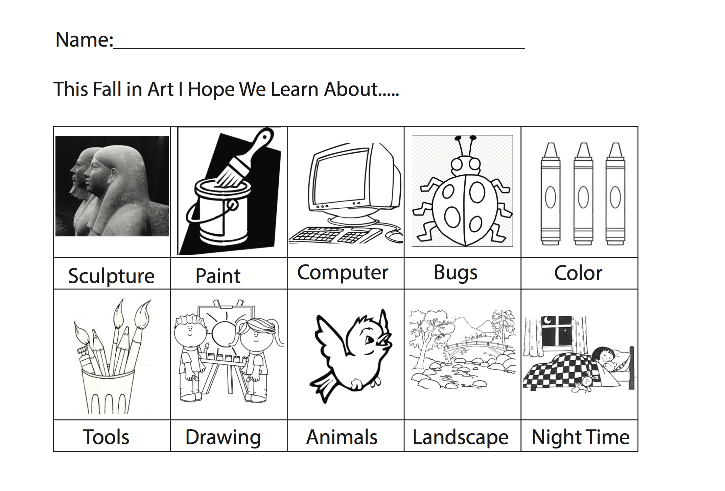
Totals:
Sculputure: 9
Paint: 5
Computer: 10
Bugs: 6
Color: 3
Tools: 2
Drawing: 3
Animals: 11
Landscape: 13
Night time: 2

Performance:
What will students accomplish as a result of this lesson? This can be presented to students in the form of a story. In this narrative the students take on a role and create a learning product about a specific topic for a certain audience. (RAFT – Role / Audience / Format / Topic)
You are an artist working with the environment. First you will explore the environment just outside your classroom to gather artifacts that you want to preserve. After having gathered artifacts, you will be documenting them in multiple ways. You will draw them from observation, you will take a rubbing of them, you will use some of them to turn into stain glass, and lastly you will make impressions with them into clay that we will fire and eventually paint.

Concepts:
List the big ideas students will be introduced to in the lesson. These ideas are universal, timeless and transferrable. Examples of concepts used in art might include: Composition, Patterns, Technique, Rhythm, Paradox, Influence, Style, Force, Culture, Space/Time/Energy, Line, Law/Rules, Value, Expressions, Emotions, Tradition, Symbol, Movement, Shape, Improvisation, and Observation Look for concepts in the standards, content specific curriculum, etc.
Observe
Composition
Preserve
Reflect

Enduring Understanding (s):
Enduring Understandings show a relationship between two or more concepts; connected with an active verb. The best enduring understandings not only link two or more concepts; but demonstrate why this relationship is important. Like concepts, they are timeless, transferrable and universal.
Artists observe their environment and gather materials to be preserved and recorded.

Standards: (All lessons should address all standards.)
1. Observe and Learn to Comprehend
2. Envision and Critique to Reflect
3. Invent and Discover to Create
4. Relate and Connect to Transfer

Objectives/Outcomes/Learning Targets:
Objectives describe a learning experience with a condition → behavior (measurable) → criterion. Aligned to: Bloom’s – Standards – GLEs - Art learning and, when appropriate, Numeracy, Literacy and Technology. Should be written as: Objective. (Bloom’s: _____ - Standard: _____ - GLE: _____ -Art learning: _____ -Numeracy, Literacy, and/or Technology)
Using a variety of objects SWBAT create a multiple compositions using inherent characteristics.
Blooms: Create
Standard: Create
GLE: Create art to communicate ideas, feelings, or emotions.
Art learning: Expressive features and characteristics of art
Literacy

Given a clay slab SWBAT construct many impressions in the clay working with 2D object and 3D object textures.
Blooms: Create
Standard: Create
GLE: Create art to communicate ideas, feelings, or emotions.
Art learning: Conceptual-Ideation and Expressive features
Numeracy

Given examples of artwork SWBAT investigate contemporary artwork from Damien Hirst, Rachel Dein and Paul Stankard with subject matter of “a freeze in time” and impressions from clay.
Blooms: Analysing
Standard: Transfer
GLE: Visual arts relate experiences to self, family, and friends.
Art learning : Historical/multicultural content
Literacy

Using completed artwork SWBAT critique their finished artwork using verbal skills to a partner.
Blooms: Evaluating
Standard: Reflect, Comprehend
GLE: Visual arts provide opportunities to respond to personal works of art and the art of others., Works of art express feelings.
Art learning: aesthetics/ transfer
Literacy

Differentiation:
Explain specifically how you have addressed the needs of exceptional students at both end of the skill and cognitive scale. Describe the strategies you will use for students who are already proficient and need growth beyond what you have planned for the rest of the class, as well as modifications for students with physical and/or cognitive challenges. Students must still meet the objectives.

Differentiation:  (Multiple means for students to access content and multiple modes for student to express understanding.) | Access (Resources and/or Process) | Expression (Products and/or Performance)
 | We will be bringing in extra “found objects” (leaves, plants, flowers, rocks, etc.) should students struggle to find some outside | Students will be assessed on their interactions with the materials as well as how they express what they intended/created.
Extensions for depth and complexity: | Access (Resources and/or Process) | Expression (Products and/or Performance)
 | When we bring extra “found objects” bring some difficult things to draw. Such as a part of a spruce tree, a rock sculpture (have them take their 5 objects and create a sculpture) then draw what they created. | Students could create multiple compositions for the rubbing project

Literacy:
List terms (vocabulary) specific to the topic that students will be introduced to in the lesson and describe how literacy is integrated into the lesson.
- observational drawings
- preserving, encase, freeze in time
- impressions
- Formaldehyde
- Realism
- Relief
- Reflective Activity ( DAY 1) (5mins)
  - Peer review
    - give feedback on their artwork
  - If time talk about these questions
    - How did we “freeze in time” or “encase” our objects?
    - Why did we do that? How do artists make decisions about their ideas and materials?
    - What inspired them for their compositions in Stained Glass, Rub Drawings and Clay?
  - Use Active Listening
- Reflective Activity (DAY 2) (15 min)
  - Gallery walk of everyone’s exploration and impression
  - Find something that is different from yours and something that is the same as yours.
  - Penguin share circle

Materials:
Must be grade level appropriate. List everything you will need for this lesson, including art supplies and tools. (These are the materials students will use.) List all materials in a bulleted format.
- crayons
- Sticky paper
- Color pencils
- collection of found nature objects
- Sketchbooks
- pencils/erasers
- clay
- glaze
- paintbrushes
- cups
- Table covers
- paper

Resources:

List all visual aids and reference material (books, slides, posters, etc. Be specific; include title, artist, etc. Make reference to where the material can be found. (These are the resources used by the teacher to support/develop the lesson.) List all resources in a bulleted format.
- Damien Hirst
  - http://damienhirst.com
  - The Incredible Journey, 2008
  - The Immortal, 1997-2005
  - 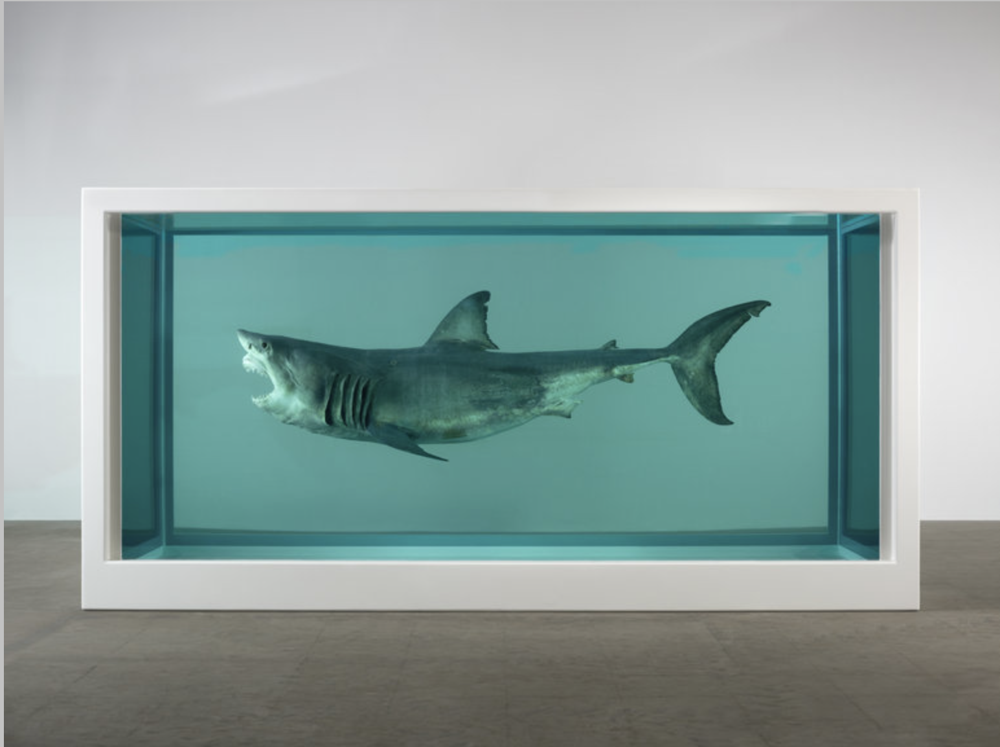
- Paul Stankard
- 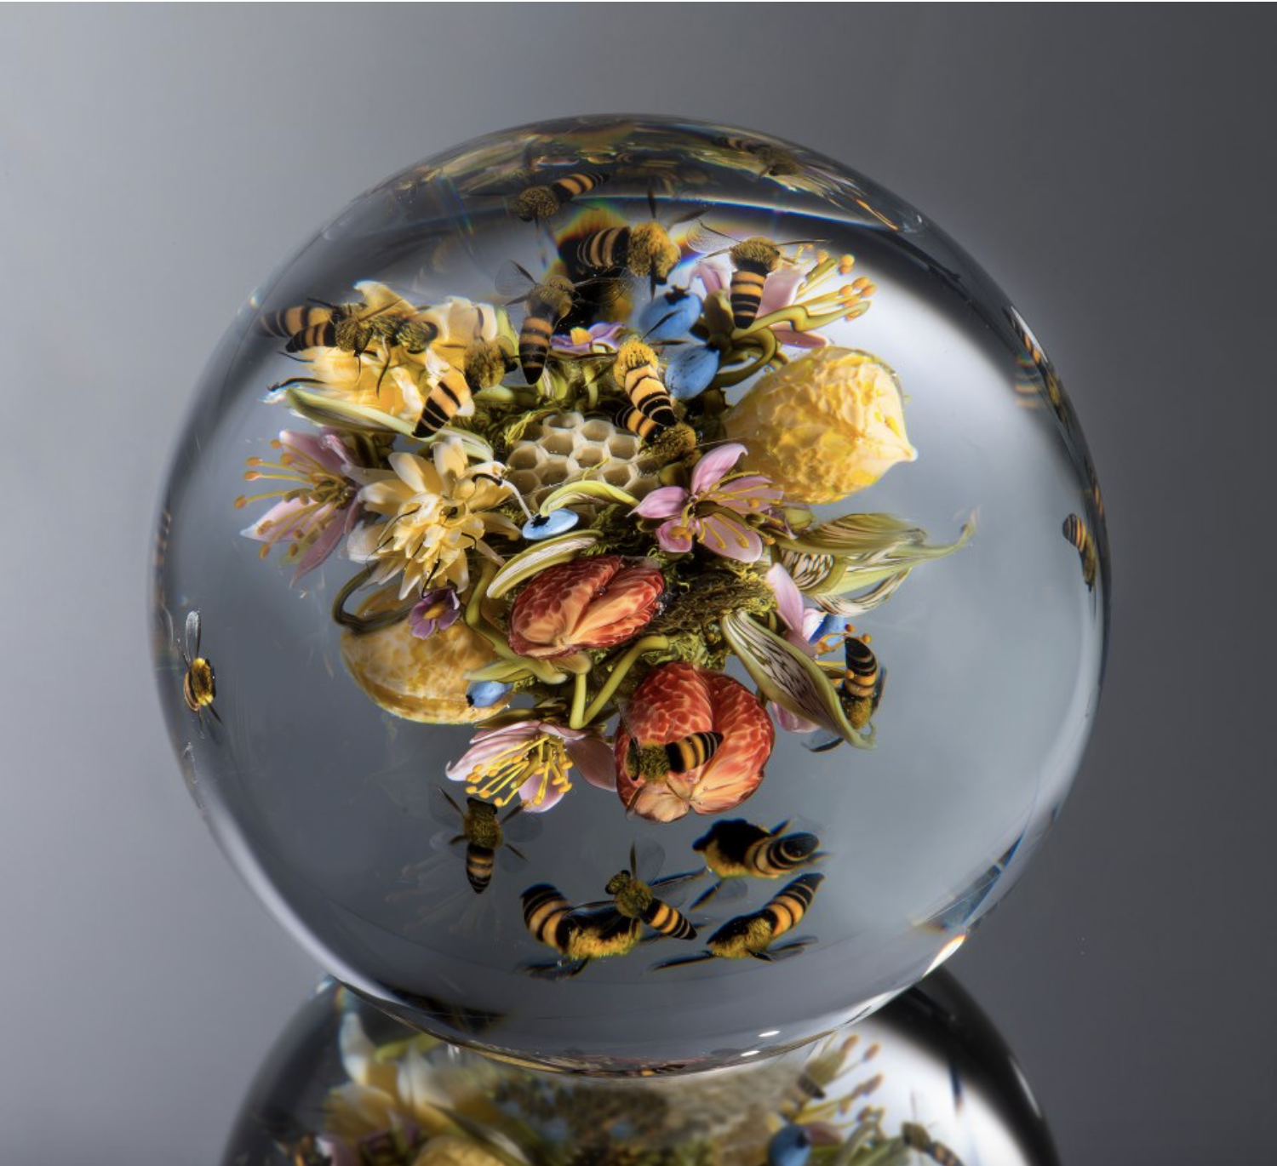
  - http://www.paulstankard.com
  - http://eggheads.altervista.org/the-beauty-of-nature-encased-in-glass/
- Rachel Dein
  - http://www.racheldein.com/gallery/
  - 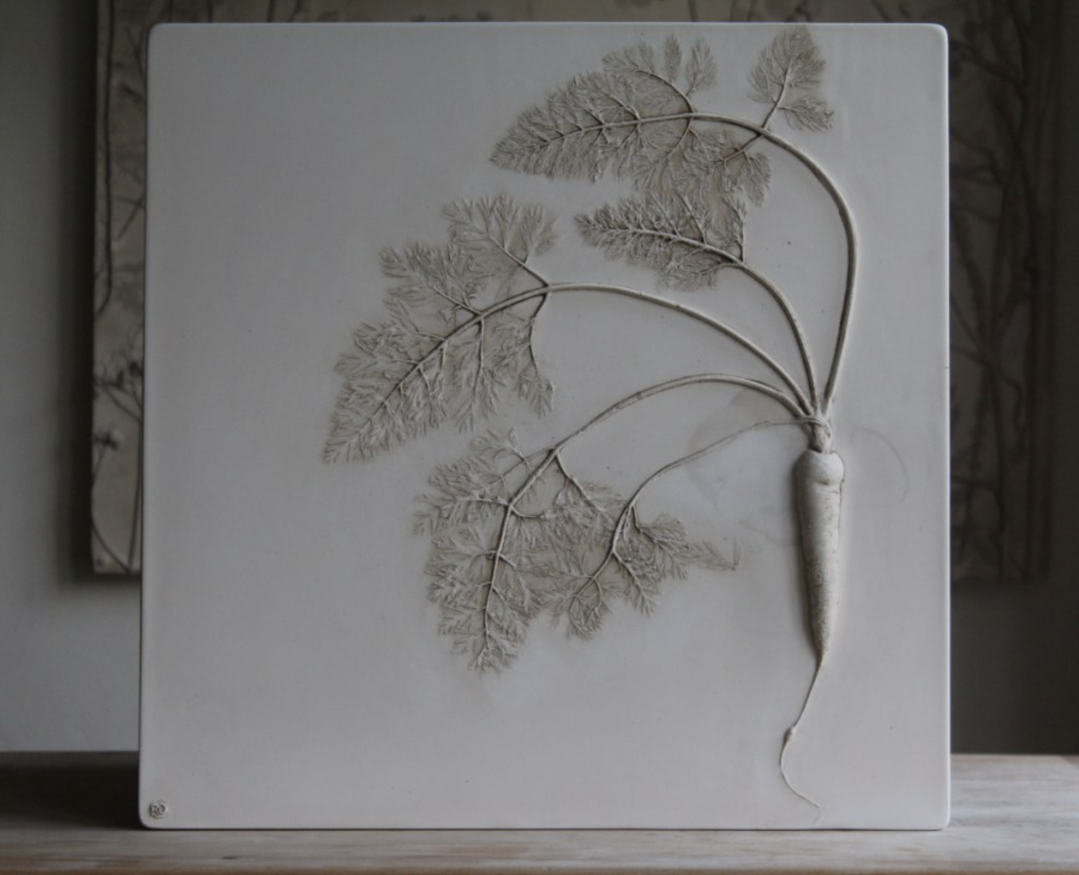
  - She uses impressions through clay then pours plaster to get the relief of the impression

Preparation:
What do you need to prepare for this experience? List steps of preparation in a bulleted format.
- Materials to be gathered
- Powerpoint of our artist and what are we going to talk about with each one
- Lesson plan
- A carrying case to carry the slabs of clay

Safety:

Be specific about the safety procedures that need to be addressed with students. List all safety issue in a bulleted format.
- But just on the nature search only safety concern is the kids run way so we just need to give them boundaries on where to find their objects.

Action to motivate/Inquiry Questions:
Describe how you will begin the lesson to stimulate student’s interest. How will you pique their curiosity and make them interested and excited about the lesson? What inquiry questions will you pose? Be specific about what you will say and do to motivate students and get them thinking and ready to participate. Be aware of the varying range of learning styles/intelligences of your students. Some ideas might include: telling a story, posing a series of questions, role-playing, etc.
What is preservation?

Ideation/Inquiry:
Ideation is the creative process of generating, developing, and communicating new ideas, where an idea is understood as a basic element of thought that can be visual, concrete or abstract. List and describe inquiry questions and processes you will engage students in to help them develop ideas and plans for their artwork.
-choice (gathered objects)
-inspiration
-composition
-preservation
-observation

Instruction:
Give a detailed account (in bulleted form) of what you will teach. Be sure to include approximate time for each activity and instructional methodology: skills, lecture, inquiry, etc. Include motivation and ideation/inquiry where appropriate; including what student will understand as a result of the art experience

Day 1 | Instruction - The teacher will... (Be specific about what concepts, information, understandings, etc. will be taught.) Identify instructional methodology. KNOW (Content) and DO (Skill)  - Introduction to what is happening that day (10 mins)  - Introduce artist Paul Stankard and Damien Hirst  - show images  - 2 images no titles by Paul Stankard  - The Incredible Journey, 2008  - The Immortal, 1997-2005  - What do you see?  - What do you think that blue stuff is?  - What do you think is happening here?  - what is preserving? (encasing, freezing in time)  - Is this preserving?  - Jumping Jacks of the day  - Gather Objects (10 each) (15 mins)  - students go outside and gather a minimum of 10 objects that they will work with (plants, rocks, natural objects)  - 5-8 must be flat objects  - Introduce Rubbings (10 mins)  - Students will be drawing in their sketchbooks  - They will place objects beneath a piece of paper and rub with crayons or colored pencils to transfer texture and shape of objects beneath  - Students will cut out the rubbings of their objects  - Students will arrange cut-outs with real objects into a composition that will be transferred to sticky paper  - Some questions to guide this conversation could include but are not limited to:  - Does anyone have symmetrical balance?  - Asymmetrical?  - Did anyone notice anything really different in anyone rubbings?  - Did you organize your plants in any special way (size, texture, shape, etc.)?  - Directions to “Stained Glass” (10 mins)  - Distribute contact paper with black line drawn down center DO NOT PEEL OFF STICKY SIDE  - Have students review their compositions and remind them that once it is ENCASED in the sticky paper then it is set and cannot be rearranged  - remind students to consider composition as they place objects and crayon shavings  - Where are you placing your items and why?  - Do you have asymmetrical balance? Symmetrical?  - Once students are happy with a composition assist them in peeling off their sticky side on their contact paper  - Students will transfer their composition of rubbings and objects onto ONE side of black line on contact paper (either right or left side  - Assist students in folding contact paper-sticking sticky sides together and encasing composition  - Intro Clay Impressions (15 mins)  - Questions to be thought about:  - Do you want to have one of your “sketches” of your rubbing be your impression?  - Do you want to see what happens when you press a lot of impressions?  - Do you want to make place the objects differently then you have before in the rubbings?  - pass out slabs  - Allow to explore through different compositions, and press objects into clay  - if done go back to rubbings  - Clean up (10mins)  - Jobs behind the front door cabinet  - Could use as well use assigned color groups to help clean floor, tables, materials and help a friend  - Have students bring slabs over to be taken to be stored until we fire them  - Reflective Activity (5mins)  - Peer review  - give feedback on their artwork  - If time talk about these questions  - How did we “freeze in time” or “encase” our objects?  - Why did we do that? How do artists make decisions about their ideas and materials?  - What inspired them for their compositions in Stained Glass, Rub Drawings and Clay?  - Use Active Listening | Learning - Students will... i.e.: explore ideation by making connections,  comparing, contrasting; synthesize possibilities for each painting technique; etc. (Be specific about what will be the intended result of the instruction as it relates to learning.) UNDERSTAND  - listening critically  - questioning deeply: raising and pursuing root or significant questions  - examining or evaluating assumptions  - analyzing or evaluating arguments, interpretations  - generating or assessing solutions  - analyzing or evaluating  - generating or assessing solutions  - analyzing or evaluating  - listening critically  - questioning deeply: raising and pursuing root or significant questions  - examining or evaluating assumptions  - analyzing or evaluating arguments, interpretations | Time
Day 2 | - Welcome Artist! (<10 min)  - What do we remember from last week?  - class website  - Surveyors -- a person who investigates or examines something  - Vocab Art Board  - What words belong there?  - Inspiration, Composition, 3D, 2D  - Jumping jacks of the day  - Take a seat at tables we are going to draw our 3D and 2D objects (5-10 min)  - Pre assessment for bugs in a jar  - Pass out a small piece of clay (10-15 mins)  - Place out a range of 3D objects at each table. Make sure to state that they won't have the same objects that they picked up but they should experiment with different ones  - Ask questions, allow exploration time  - Do you want to create something 3D or 2D?  - Come back to rug  - Impression Artist (5-10 mins)  - Rachel Dein  - What do you see?  - What are those 3D shapes?  - What do you think they are called?  - Vocab: Relief, impressions  - Relief- A type of sculpture in which form projects from a background; shallow  - Intro Clay Impressions (20 mins)  - Questions to be thought about:  - If your 2D objects are going to be pressed into the clay, how do you think the 2D would differ from the 3D objects when pressed into the clay? Why do you think that?  - Do you want to make a “sketches” of your rubbing be your impression?  - Do you want to sketch out how you are going to place them before you press the objects in?  - Do you want to see what happens when you press a lot of impressions?  - Do you want to make place the objects differently then you have before in the rubbings?  - Write a name small in corner  - Demo of making a hole for hanging  - take a back of a marker and press all the way through  - when done with one side flip over to add more impressions  - pass out slabs  - Allow to explore through different compositions, and press objects into clay  - Must use at least three 3D objects  - Reflective Activity (15 min)  - Gallery walk of everyone’s exploration and impression  - Find something that is different from yours and something that is the same as yours.  - Penguin share circle  - What vocab words do we need to add to our list  - Clean up (5-10 min)  - Jobs behind the front door cabinet  - Could use as well use assigned color groups to help clean floor, tables, materials and help a friend  - Have students bring slabs over to be taken to be stored until we fire them | - listening critically  - questioning deeply: raising and pursuing root or significant questions  - examining or evaluating assumptions  - analyzing or evaluating arguments, interpretations  - generating or assessing solutions  - analyzing or evaluating  - questioning deeply: raising and pursuing root or significant questions  - comparing and contrasting ideals with actual practice

Student reflective/inquiry activity:
Sample questions and activities (i.e. games, gallery walk, artist statement, interview) intended to promote deeper thinking, reflection and refined understandings precisely related to the grade level expectations. How will students reflect on their learning? A participatory activity that includes students in finding meaning, inquiring about materials and techniques and reflecting about their experience as it relates to objectives, standards and grade level expectations of the lesson.)
Peer review (turn & talk)
- Peer review ( turn and talk)
  - Give feedback on their artwork
- If time talk about these questions
  - How did we “freeze in time” or “encase” our objects?
  - Why did we do that?
  - What inspired them for their compositions in Stained Glass, Rub Drawings and Clay?
- Active Listening
Gallery Walk
- Look for something different look for something the same as yours
- Penguin Share Circle to share our findings

Post-Assessment (teacher-centered/objectives as questions):  Have students achieved the objectives and grade level expectations specified in your lesson plan? | Post-Assessment Instrument:  How well have students achieved the objectives and grade level expectations specified in your lesson plan? Include your rubric, checklist, rating scale, etc.
Can students create multiple compositions using inherent characteristics?  Can students construct many impressions in the clay working with 2D object and 3D object textures?  Can students investigate contemporary artwork from Damien Hirst, Rachel Dein and Paul Stankard.  Can students critique their finished artwork using verbal skills to a  partner. | - create multiple compositions using inherent characteristics  - construct many impressions in the clay working with 2D object and 3D object textures  - investigate contemporary artwork  - critique their finished artwork using verbal skills
4 Advanced
- Create 5 compositions using inherent characteristics
- Construct many 5 or more impressions in the clay working with both 2D object and 3D object textures
- Extremely investigate contemporary artwork
- critique their finished artwork using verbal skills extremely well
3 Proficient
- Create 3-4 compositions using inherent characteristics
- Construct many 4 or more impressions in the clay working with both 2D object and 3D object textures
- investigate contemporary artwork well
- critique their finished artwork using verbal skills very well
2 Partially Proficient
- Create 1-2 compositions using inherent characteristics
- Construct many 3 or more impressions in the clay working with only 1 set of 2D object or 3D object textures
- Moderately investigate contemporary artwork
- critique their finished artwork using verbal skills moderately
1 In Progress
- Create 0-1 compositions using inherent characteristics
- Construct many 2 or more impressions in the clay working with both 2D object and 3D object textures
- Barely investigate contemporary artwork
- critique their finished artwork using verbal skills barely
 | 0 Didn't Complete

Self-Reflection:
After the lesson is concluded write a brief reflection of what went well, what surprised you, and what you would do differently. Specifically address: (1) To what extent were lesson objectives achieved? (Utilize assessment data to justify your level of achievement.) (2) What changes, omissions, or additions to the lesson would you make if you were to teach again? (3)What do you envision for the next lesson? (Continued practice, reteach content, etc.)
Clarissa Brobst
CLASS: #1
September 19, 2017
This was the first real art class that I have taught before to a group of students. I think what went really well was having the kids engaged the whole time. Even in our sketchbook class. And also over planning so that we could also finish the second day. We really worked on our inherent characteristics with compositions. I think it will be really important for us to keep talking about the vocab words and what they mean in class so the students to use it in their other lessons.
I think I take this very seriously so I’m very hard on myself when something doesn’t go quite right. I’ll think about it over and over and how I could change it differently. So I think after class on Friday I didn’t feel like I did my best. I didn’t quite take charge at the beginning and Katie stepped in and did it. So I think that I need to communicate better and print out our lesson plan or at least our instruction section to help remind me the times and what to talk about.
As we learn more in class the more I want to remember and add to my tools as a future art teacher. I think something that is has happened both times in class is that when we are demoing or we are having peer review. Having things or objects in front of students is really hard for them not to want to touch and play with. And Dense has worked with them on this we just need to apply her methods to have the kids keep hands off. Or we need to move to the rug to talk so attending skills are on and present. So I actually put this into our lesson plan for this week to help us move around the room and have an easier time with listening.

Katie Mills
CLASS: #1
9/20
It's always a little nerve-racking heading into class wanting things to go well. Clarissa and I came early to set everything up. Our anticipatory set was successful in that students were excited and engaged as we clicked through slides of artist work. We tried to introduce a lot of our questions for the day: What is preservation? What is composition? Why do artists save things? Students answered questions and came up to interact with the smartboard. Students gathered objects found their seats and began the rubbing drawings pretty seamlessly. Prompting thoughts about composition and transferring to contact paper was successful as well. One planning thing I would have done differently in that students needed a great deal of assistance both in peeling the contact paper AND folding and encasing their compositions in the contact paper and these steps were back to back and so Clarissa and I were spread a little thin in assisting everyone. I would, in the future, put a buffer step in between the two or just space them differently in general. One other unexpected thing was not having time to get to our clay activity. But this was surprisingly ok. We were able to use the little bit of extra time in class to capitalize on our reflections and that was really worth-while. I was reminded that my goal as a teacher isn't to crank through as many as activities as possible but to allow for each activity to have the time to develop into a meaningful experience for students.

Clarissa Brobst
CLASS: #2
DATE: 9/25

What went well for this class two was many things. From writing the last journal I think printing out the lesson plan really worked out well. Other things that worked well was having the students explore the clay for 15 mins. This really got the students excited to make impressions. They even tried to make impressions and see what would happen. There was one student that flipped a page in her note book and started to ‘draw’ with the clay. Experimenting and taking risk really happened during this time. Aside from the exploration time other things that worked were having the students leave the table to give more instructions. Also having Katie already having the clay slabs cut for when the students were ready for them. Made it for an easy transition.
What didn’t go well was I think I honestly forget that they don’t know what I already know. So when I was introducing the pre-assessment I did a quick demo and I started to draw out observational drawing of a stick. I didn’t even think they would just want to draw a line because that is what a stick looks like. I was glad Katie stepped in and thought of it.
I think we need to write down the vocab instead of writing them on the smart board. This will way we will have the vocab up on the board for the students to refer back to.

Katie Mills
Lesson 1, Day 2
9/22/17
What worked well:
Clarissa had the good idea of printing out this week's lesson and I will definitely be doing that in the future. It's a comfort to have it there to reference. The anticipatory set went really well. We quickly reviewed last week via our blog and students were excited to see photos of what they'd done. Following that, Clarissa put together an exciting line-up of artist work and students were eager to ask questions and engage with the presentation. Another element that went surprisingly well was the distribution of 3D objects. Students had collected several objects last week but when we ran out of time for the clay activity, we collected the objects. I was concerned that in distributing them again, students would be tied to the specific ones they had found. But I expressed this concern to Denise before class and she made the good point that it is all in the wording and presentation for this age group. And so we explained it to them that while we had gathered the objects individually, we now combined them in a community bag and would be allowed to pick three out to work with for the day and students responded without a hitch. The observational drawing pre-assessment went well too. Denise explained that they have had a little exposure to this. And when asked about their decisions, students were able to specify details they had noticed and attempted to recreate from their objects in their drawings. This was a small win. Prefacing our project, we allowed the students to play with the clay (a recommendation from Denise last week) and I'm so glad we did! It got some of the excitement jitters out and it allowed students to preemptively explore combining their found objects with clay. I am so appreciative to have a co-teach like Clarissa because we are able to bounce off each other and jump in whenever-it worked out well that I cut clay while Clarissa demoed so that when she was done students came and got their tiles.
What didn't work well:
I think one of the greatest downfalls of the lesson was vocab. And it seems kind of minor but it is driving a lot of our key concepts and I couldn't help but feel really disappointed in our teaching to see so many of the students unsure of what they were doing. One thing I think we have working against us is that many of our vocab words end in "tion" i.e. inspiration, composition, impressions, and preservation. Another element, however, is that we still haven't set up a permanent word wall (even though Denise gave us a space.) Instead, we wrote it on a slide on the smart board and I'm afraid that because it was such a quick review, the students didn't get much out of it. Student reflections were ok but not as strong as last week. Students weren't making deeper level thinking comments.
What I would do differently:
We will definitely spend a little time over at the word wall, putting up and reviewing some of our vocab. I also want to reiterate vocab when reviewing our blog and previous explorations so that students can associate an experience with a term and solidify that meaning. i.e. with "inspiration" remind them of our artist introduction presentations. Next lesson, I really want to develop some thought-provoking and developed questions for reflection. We are having students do both a mid-class turn-and-talk feedback time, as well as a group one at the end. I want to develop questions that will encourage students to grapple with concepts from the day in a meaningful way.

Appendix: Include all handouts, prompts, written materials, rubrics, etc. that will be given to students.

8/9/15 Fahey

