Lesson Plan Title: Bugs in a Jar Length: 2 class

Note: Before you plan and write art experiences; pre-assess your students based on the proposed concepts, enduring understandings, and objectives of the unit/lesson(s). You may also gather this information from (previous) teachers, by reviewing already completed art work, consulting curriculum materials, etc., to get a better understanding of what content students already know and what they will need to know to be successful.

Pre-Assessment:
This will need to be done prior to teaching your lesson. Outline the method you will use to determine the skill/knowledge level of your students based on the concepts/enduring understandings/objectives of the lesson. (Hint: turn these into questions.) Be specific in describing what you would recognize as proficient skill/knowledge.
- Take a seat at tables we are going to draw our 3D and 2D objects (5-10 min)
  - Pre assessment for bugs in a jar
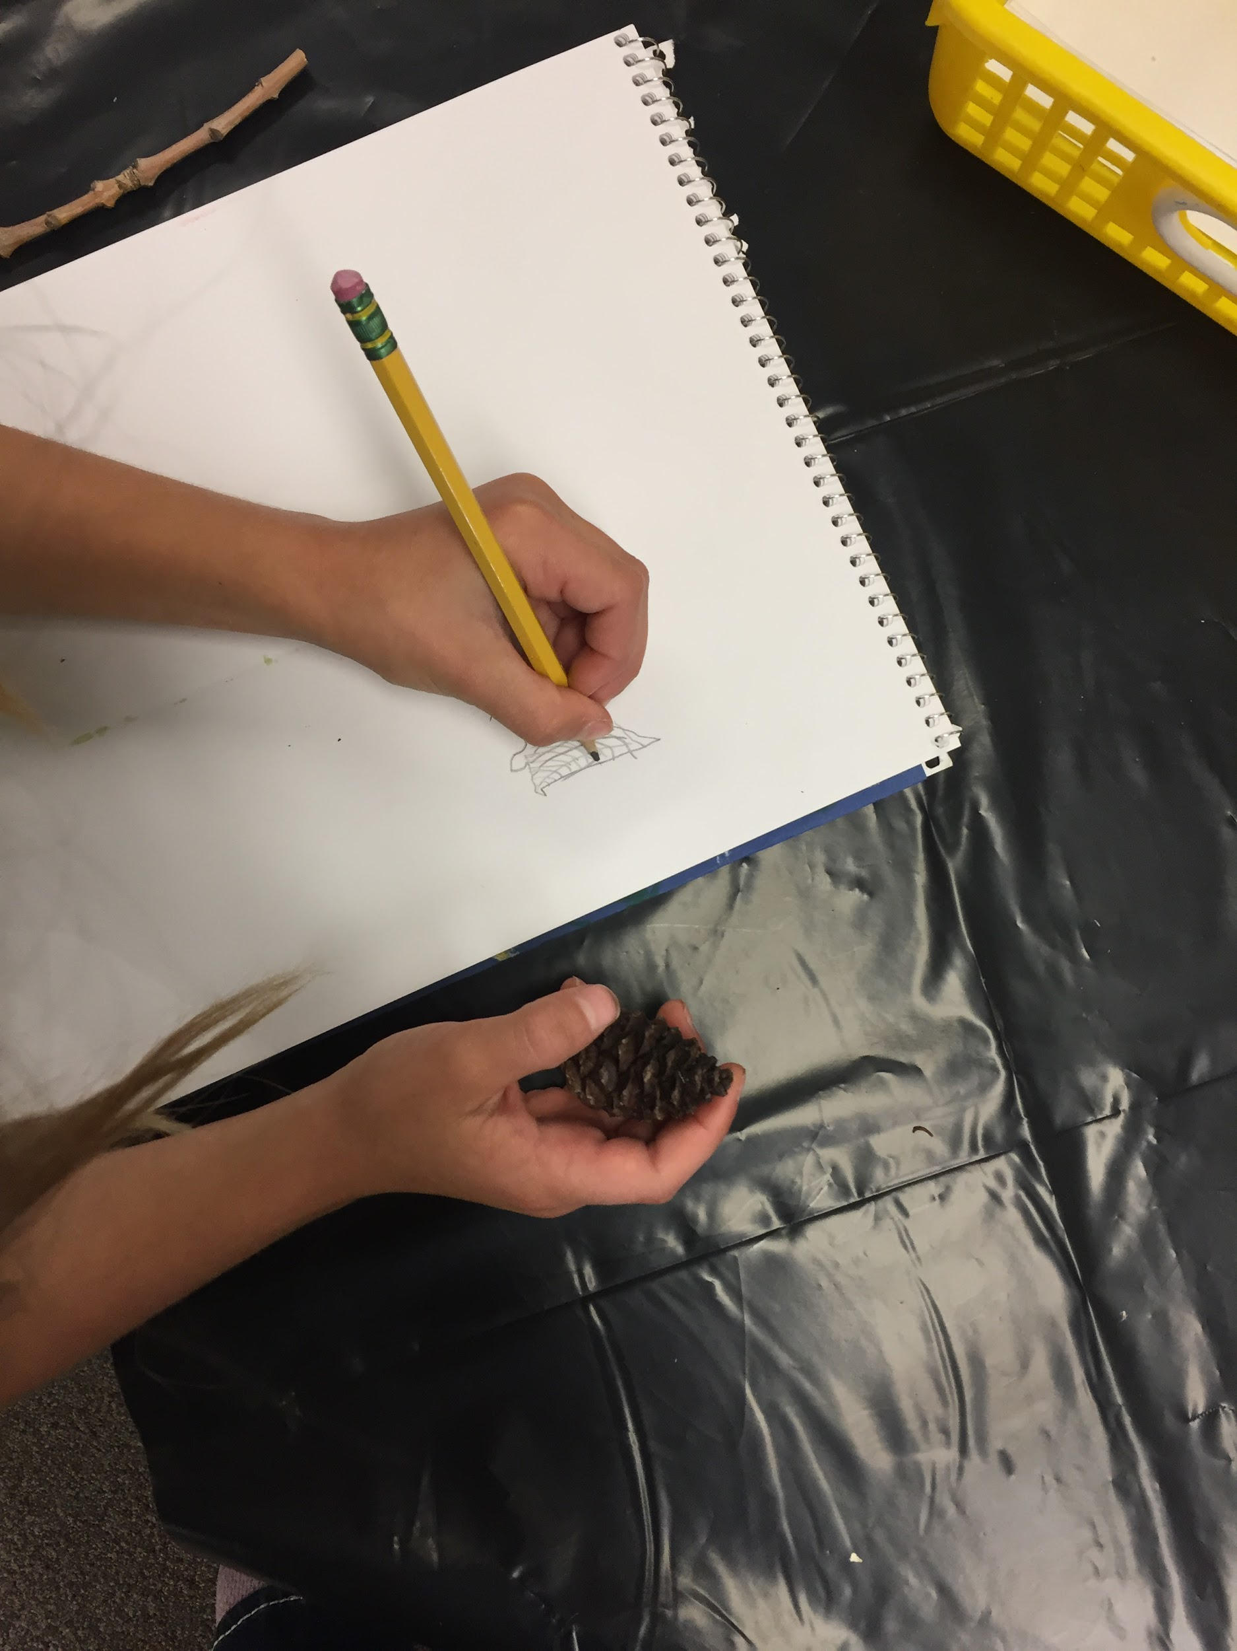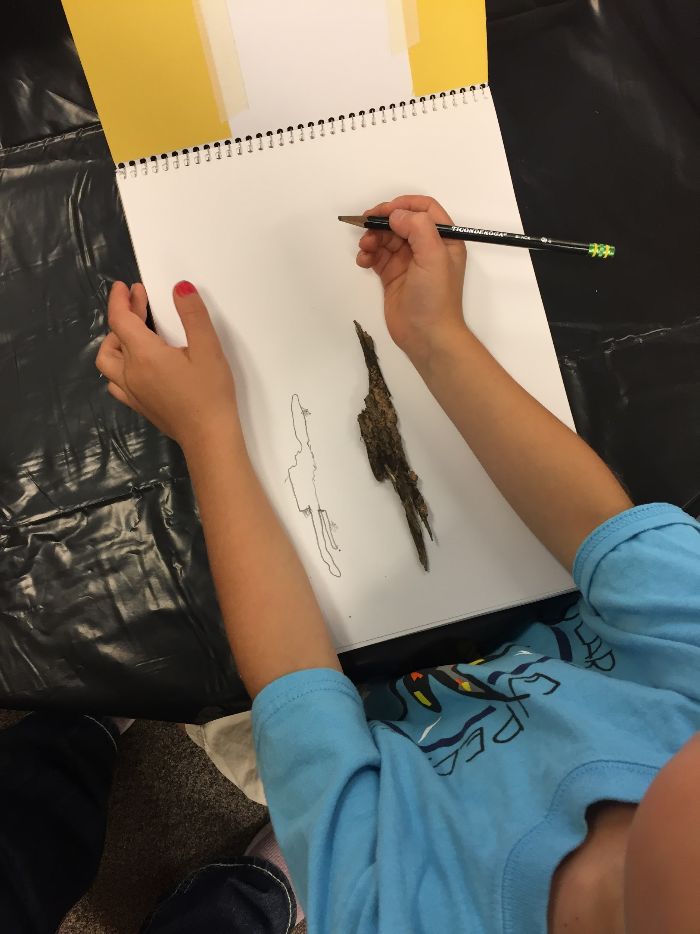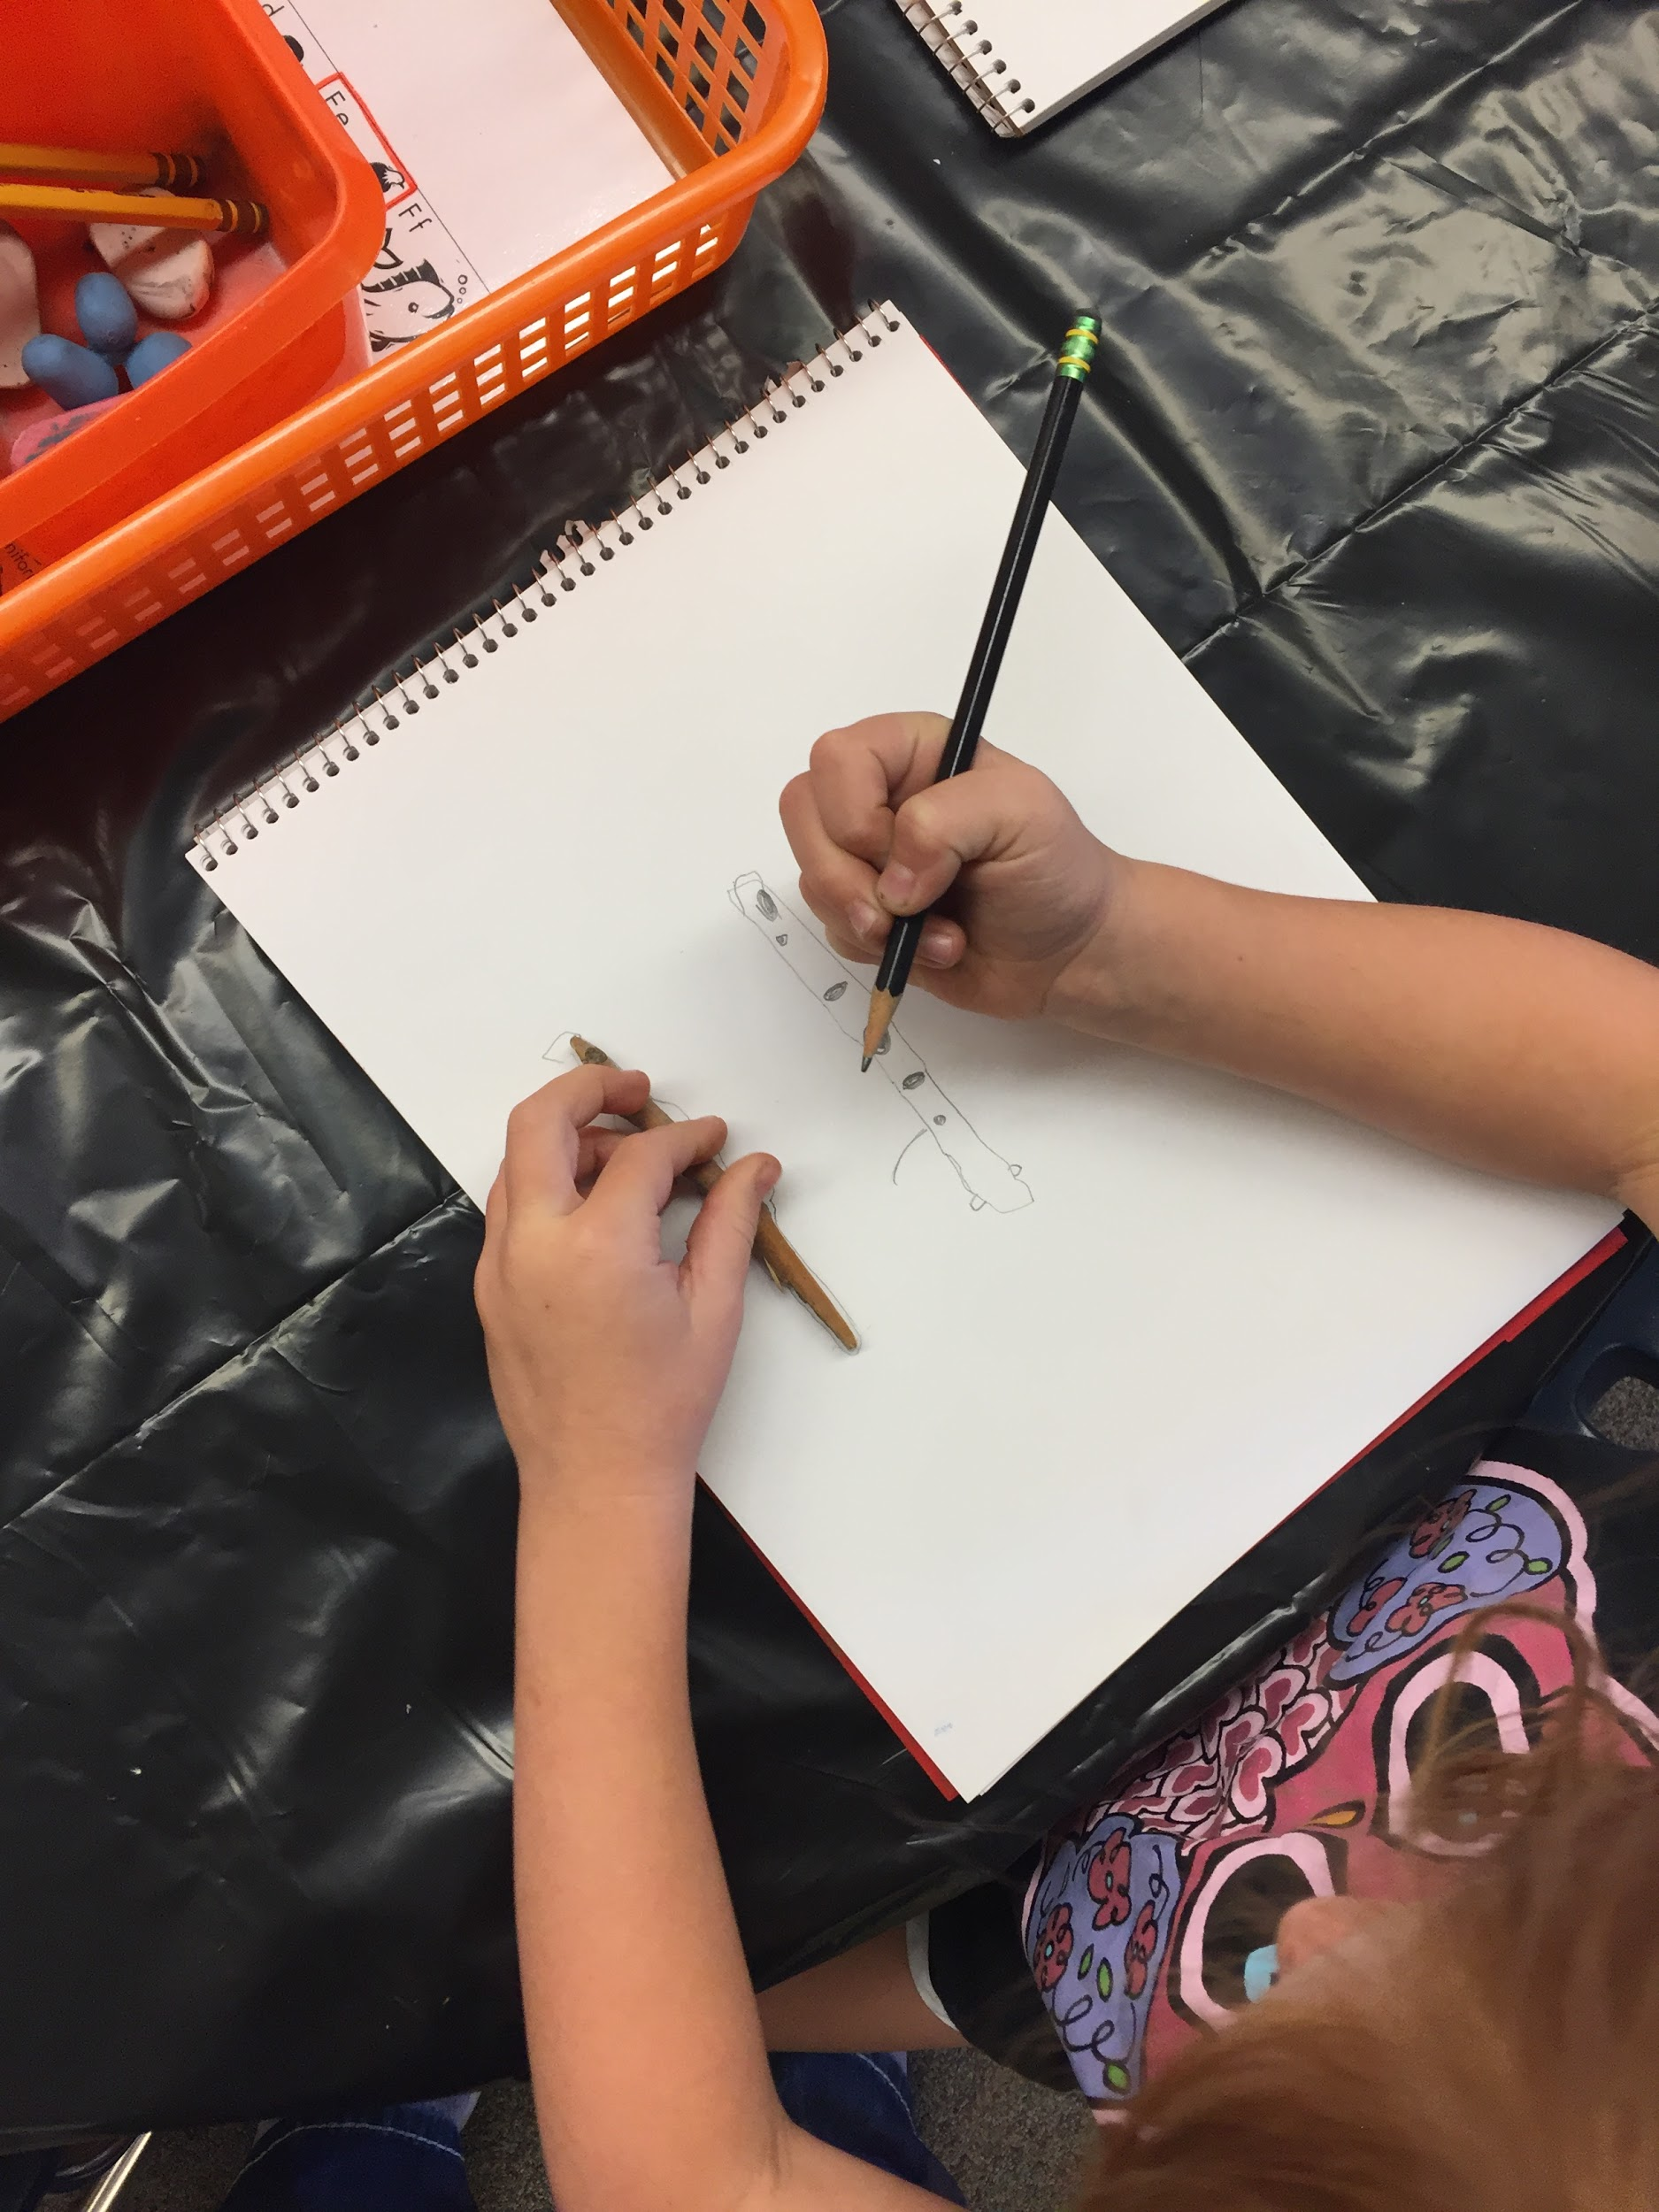

- Some students traced the objects
- Some student try really looking at it like with the pine cone
- Some didn’t “know” how to draw it

Performance:
What will students accomplish as a result of this lesson? This can be presented to students in the form of a story. In this narrative the students take on a role and create a learning product about a specific topic for a certain audience. (RAFT – Role / Audience / Format / Topic)
Students will be given bug pictures as well as bug species in glass containers in which to draw insects from observation. Students will be asked to practice “slow looking” and drawing from what they see rather than what they traditionally know. Students will be using black paper, metallic paints and focus on documentation. After drawing their bugs students will place their individual bugs in a huge class jar that is drawn on paper so they have a community of bugs.

Concepts:
List the big ideas students will be introduced to in the lesson. These ideas are universal, timeless and transferrable. Examples of concepts used in art might include: Composition, Patterns, Technique, Rhythm, Paradox, Influence, Style, Force, Culture, Space/Time/Energy, Line, Law/Rules, Value, Expressions, Emotions, Tradition, Symbol, Movement, Shape, Improvisation, and Observation Look for concepts in the standards, content specific curriculum, etc.
Observation
Line
Composition
Reflect

Enduring Understanding (s):
Enduring Understandings show a relationship between two or more concepts; connected with an active verb. The best enduring understandings not only link two or more concepts; but demonstrate why this relationship is important. Like concepts, they are timeless, transferrable and universal.
Artists can take observations by using composition and line.

Standards: (All lessons should address all standards.)
1. Observe and Learn to Comprehend
2. Envision and Critique to Reflect
3. Invent and Discover to Create
4. Relate and Connect to Transfer

Objectives/Outcomes/Learning Targets:
Objectives describe a learning experience with a condition → behavior (measurable) → criterion. Aligned to: Bloom’s – Standards – GLEs - Art learning and, when appropriate, Numeracy, Literacy and Technology. Should be written as: Objective. (Bloom’s: _____ - Standard: _____ - GLE: _____ -Art learning: _____ -Numeracy, Literacy, and/or Technology)
Using a variety of bugs SWBAT create multiple compositions using inherent characteristics.
Bloom’s: Creating
Standard: Create
GLE: Create art to communicate ideas, feelings, or emotions.
Art learning: Expressive features and characteristics of art
Numeracy, Literacy

Given completed artwork SWBAT compare and contrast the individual vs. group by class discussion.
Bloom’s: Analysing
Standard: Reflect
GLE: Visual arts provide opportunities to respond to personal works of art and the art of others.
Art learning: Critical reflection
-Literacy

Given examples of artwork SWBAT investigate two techniques from examples Matthew Bohan, Marcello Barenghi, Elsa Depont of observational drawings.
Bloom’s: Analysing
Standard: Comprehend
GLE: Art represents and renders the stories of people, places, or things.
Art learning: Historical/multicultural content
Numeracy

Using last two weeks as review SWBAT relate and remember back to what they had learned through class discussion.
Bloom’s: Understanding
Standard: Transfer
GLE: Visual arts relate experiences to self, family, and friends.
Art learning: aesthetics/transfer
Literacy

Differentiation:
Explain specifically how you have addressed the needs of exceptional students at both end of the skill and cognitive scale. Describe the strategies you will use for students who are already proficient and need growth beyond what you have planned for the rest of the class, as well as modifications for students with physical and/or cognitive challenges. Students must still meet the objectives.

Differentiation:  (Multiple means for students to access content and multiple modes for student to express understanding.) | Access (Resources and/or Process) | Expression (Products and/or Performance)
 |  | Students will be assessed on their interactions with the materials as well as how they express what they intended/created.
Extensions for depth and complexity: | Access (Resources and/or Process) | Expression (Products and/or Performance)
 |  | Students could do one or two then if they want a challenge pick a bug or a part of a bug that is really complex and focus on one section

Literacy:
List terms (vocabulary) specific to the topic that students will be introduced to in the lesson and describe how literacy is integrated into the lesson.
Vocab
- Surveyor
  - Shown through the website, to help explain what the students will be doing in class
- We will review vocab and add it to the word wall
  - inspiration (week 1)
  - 2-dimensional (week 2)
  - 3-dimensional (week 2)
  - composition (week 2)
  - preservation (week 2)
  - impression (week 3)
- Students will turn and talk to give peer feedback on observational drawing
  - What is one thing in your partner's drawing that they did really well? What is one thing they could work on? Are we looking slowly and taking our time? Are we noticing details?
- Once students have taped insects in either class jar or sketchbook. Students will gather on rug and we will have a class reflection about our class jar. Prompts for discussion can include: How did our insects change once put in the class jar? How did composition change? Why might artists work collaboratively? How did scale change?

Materials:
Must be grade level appropriate. List everything you will need for this lesson, including art supplies and tools. (These are the materials students will use.) List all materials in a bulleted format.
- Black paper
- Metallic paint
- Paint brushes
- Cups for water
- White colored pencils
- Siccors
- Tape

Resources:

List all visual aids and reference material (books, slides, posters, etc. Be specific; include title, artist, etc. Make reference to where the material can be found. (These are the resources used by the teacher to support/develop the lesson.) List all resources in a bulleted format.
- 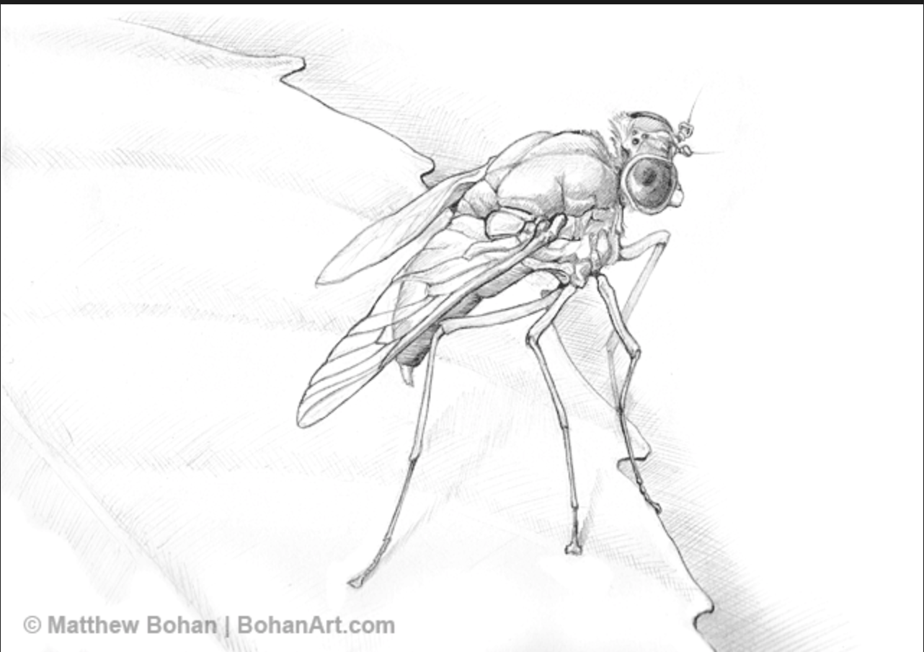
  - Matthew Bohan
- 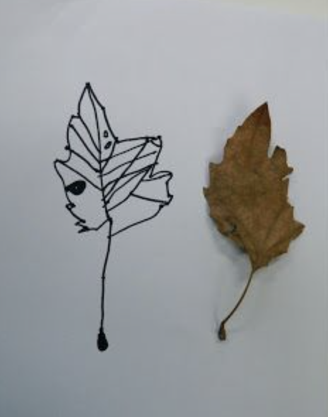
  - example of observational drawing
- 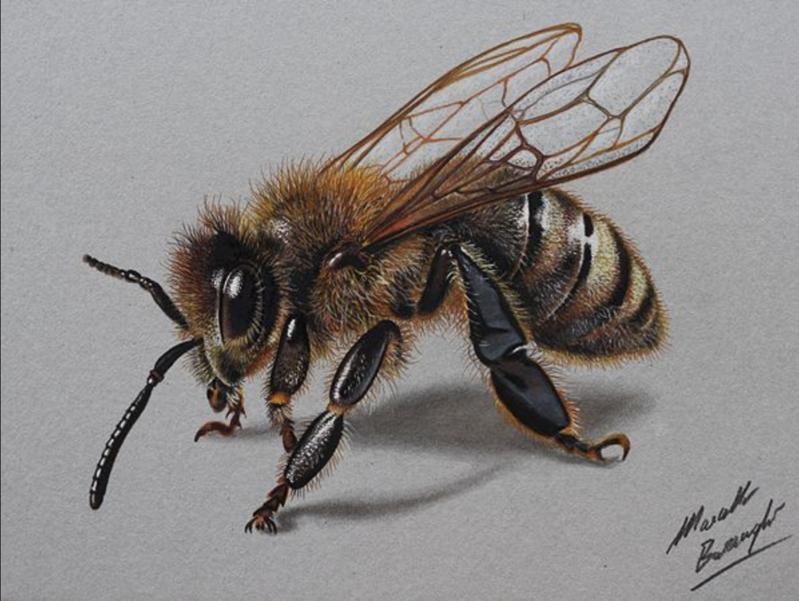
  - Marcello Barenghi
- time lapse
- 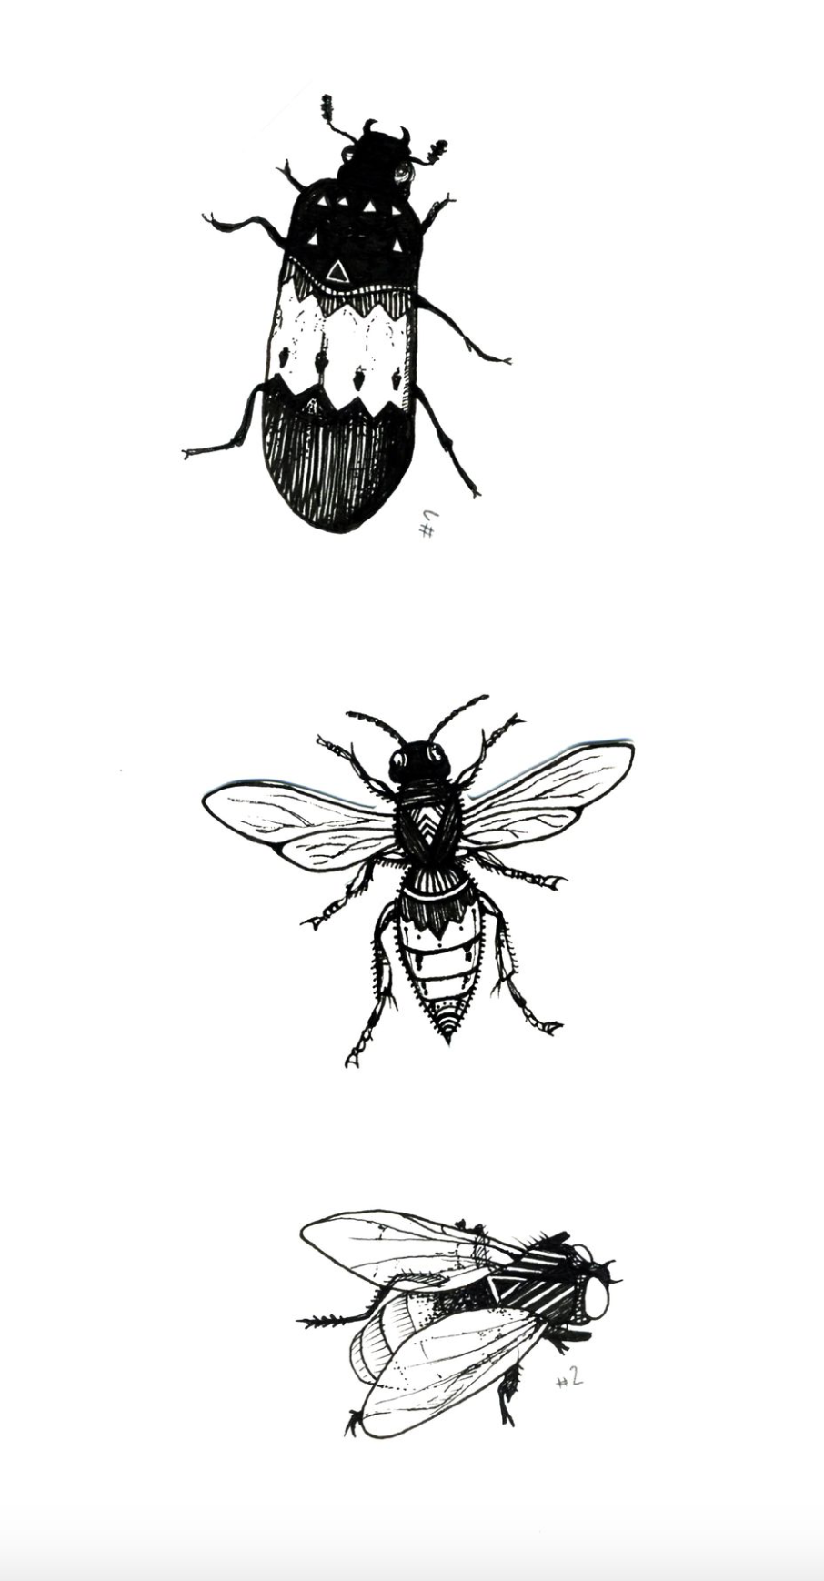
  - Elsa Depont

Preparation:
What do you need to prepare for this experience? List steps of preparation in a bulleted format.
- Create big jar
- Gather supplies
- Create Vocab List to add too and so the kids reference
- Bug displays

Safety:

Be specific about the safety procedures that need to be addressed with students. List all safety issue in a bulleted format.
No safety concerns.

Action to motivate/Inquiry Questions:
Describe how you will begin the lesson to stimulate student’s interest. How will you pique their curiosity and make them interested and excited about the lesson? What inquiry questions will you pose? Be specific about what you will say and do to motivate students and get them thinking and ready to participate. Be aware of the varying range of learning styles/intelligences of your students. Some ideas might include: telling a story, posing a series of questions, role-playing, etc.
We will begin by quickly reflecting and connecting what we did last week. We will then go into some slides of contemporary observational artists and this time lapse video of a drawing of a butterfly. We will ask questions like: What are these artists drawing? How do you think they are drawing them? Do you think the artist is just doing this from their imagination? How long do you think it takes for the artists to draw these objects? How do they get all the details?

Ideation/Inquiry:
Ideation is the creative process of generating, developing, and communicating new ideas, where an idea is understood as a basic element of thought that can be visual, concrete or abstract. List and describe inquiry questions and processes you will engage students in to help them develop ideas and plans for their artwork.
Students will be given choice of resource material for their observational drawing of their bug. They will have laminated images to choose from as well as bugs that have been preserved in small vials. During demonstration of observational drawing, students will be given insight into the questions we ask while drawing observationally: What size is that? How many are there? What texture is that? What mark can I make to show that texture? Am I drawing what I see or am I drawing from my imagination?

Instruction:
Give a detailed account (in bulleted form) of what you will teach. Be sure to include approximate time for each activity and instructional methodology: skills, lecture, inquiry, etc. Include motivation and ideation/inquiry where appropriate; including what student will understand as a result of the art experience

Day 1 | Instruction - The teacher will... (Be specific about what concepts, information, understandings, etc. will be taught.) Identify instructional methodology. KNOW (Content) and DO (Skill)  Students will begin gathered on the rug  - 8:15-8:25 We will refer back to what we did last week via the blog post and recall how we began drawing observationally  - We will review vocab and add it to the word wall  - inspiration (week 1)  - 2-dimensional (week 2)  - 3-dimensional (week 2)  - composition (week 2)  - preservation (week 2)  - impression (week 3)  and intro new word:  - surveyor (week 4)  - 8:25-8:32 Students will be introduced to new artists for the week with a slide presentation here:  - Matthew Bohan  - Marcello Barenghi  - Elsa Depont  - What are these artists drawing? How do you think they are drawing them? How long do you think it takes for the artists to draw these objects? How do they get all the details?  - time lapse video (same questions)  - 8:32-8:35 We will introduce resources students will have to draw from: photos of bugs and vials of bugs. Students will pick one at a time for each drawing (there will be three drawings total). i.e. for drawing one students will each pick a resource, then return their resource and pick again for drawing two.  - 8:35-8:43 Students will gather around a table to watch a demonstration of observational drawing. Starting with a single black piece of paper, students will draw their bug with white colored pencils. Teacher will demonstrate questions we ask when drawing observationally: What size is that? How many are there? What texture is that? What mark can I make to show that texture? Am I drawing what I see or am I drawing from my imagination?  - 8:43-8:46 Students will turn and talk to give peer feedback on observational drawing  - What is one thing in your partner's drawing that they did really well? What is one thing they could work on? Are we looking slowly and taking our time? Are we noticing details?  - 8:46-8:55 Students will then draw two more bugs on two different pieces of paper  - 8:55-9:15 Students will regather for second part of demonstration. Now that they have the drawings of their bugs, students are going to go in using metallic paint and fill in/add more detail to their bugs. Each table will be given gold, copper, silver, and bronze paint to work with, brushes, water to rinse in, and paper towels to dry their brushes off. Students will paint all three of their bugs  - 9:15-9:20 Students will choose two bugs to be taped into the class jar (jar drawn on big piece of paper) and one bug to be taped into their sketchbooks. Students will also clean up at this point.  - 9:20-9:30 Students will gather in front of class jar on rug to answer questions and reflect. What is the composition of our bugs in the jar? How does your individual bug function differently in the group artwork? Do you see any examples of close observation and/or slow looking? | Learning - Students will... i.e.: explore ideation by making connections,  comparing, contrasting; synthesize possibilities for each painting technique; etc. (Be specific about what will be the intended result of the instruction as it relates to learning.) UNDERSTAND  - thinking precisely about thinking: using critical vocabulary  - listening critically  - questioning deeply: raising and pursuing root or significant questions  - examining or evaluating assumptions  - analyzing or evaluating arguments, interpretations  - listening critically  - questioning deeply: raising and pursuing root or significant questions  - examining or evaluating assumptions  - analyzing or evaluating arguments, interpretations  - comparing and contrasting ideals with actual practice  - listening critically  - questioning deeply: raising and pursuing root or significant questions | Time
Day 2 | - 8:15-8:30 With students gathered on rug, we will begin class with reflection of last week  - -Review blog  - -Review word wall  - 8:30-8:50 Students will be given paint and materials from last week to revisit some of their explorations from last week. Metallic paint, images of insects, and black paper will be at every table. Students need to complete at least two insects but can make more. (For students that were absent last week, they will be asked just to complete one)  - 8:50-9:10 Students will choose at least one insect to put in the class jar (a big paper jar) and at least one to put in their sketchbook. If they have extra, they can choose whether they want to put it in their sketchbook or in the class jar.  - 9:10-9:15 Once students have taped insects in either class jar or sketchbook. Students will gather on rug and we will have a class reflection about our class jar. Prompts for discussion can include: How did our insects change once put in the class jar? How did composition change? Why might artists work collaboratively? How did scale change?  - 9:15-9:20 Give students oil pastels. Given the chance to explore.  - 9:20-9:30 Pre-Assessment to Flight of fancy. Draw the birds with oil pastels using observational drawing. | - thinking precisely about thinking: using critical vocabulary  - comparing and contrasting ideals with actual practice  - listening critically  - questioning deeply: raising and pursuing root or significant questions

Student reflective/inquiry activity:
Sample questions and activities (i.e. games, gallery walk, artist statement, interview) intended to promote deeper thinking, reflection and refined understandings precisely related to the grade level expectations. How will students reflect on their learning? A participatory activity that includes students in finding meaning, inquiring about materials and techniques and reflecting about their experience as it relates to objectives, standards and grade level expectations of the lesson.)
Peer Review For Individual Bugs
- Partner feedback
  - What is one thing in your partner's drawing that they did really well? What is one thing they could work on? Are we looking slowly and taking our time? Are we noticing details?
Group Discussion
- What is the composition of our bugs in the jar? How does your individual bug function differently in the group artwork? Do you see any examples of close observation and/or slow looking?

Post-Assessment (teacher-centered/objectives as questions):  Have students achieved the objectives and grade level expectations specified in your lesson plan? | Post-Assessment Instrument:  How well have students achieved the objectives and grade level expectations specified in your lesson plan? Include your rubric, checklist, rating scale, etc.
Can students create multiple compositions using inherent characteristics?  Can students given completed artwork compare and contrast the individual vs. group by class discussion?  Can students investigate two techniques from examples Matthew Bohan, Marcello Barenghi, Elsa Depont of observational drawings?  Can students relate and remember back to what they had learned through class discussion? | - create multiple compositions using inherent characteristics  - completed artwork compare and contrast the individual vs. group by class discussion  - investigate two techniques from examples Matthew Bohan, Marcello Barenghi, Elsa Depont of observational drawing  - relate and remember back to what they had learned through class discussion
4 Advanced
- create 5 compositions using inherent characteristics
- completed artwork compare and contrast the individual vs. group by class discussion contributed extremely
- investigate more than two techniques from examples Matthew Bohan, Marcello Barenghi, Elsa Depont of observational drawing
- relate and remember back to what they had learned through class discussion contributed extremely
3 Proficient
- create 3-4 compositions using inherent characteristics
- completed artwork compare and contrast the individual vs. group by class discussion contributed
- investigate two techniques from examples Matthew Bohan, Marcello Barenghi, Elsa Depont of observational drawing
- relate and remember back to what they had learned through class discussion contributed
2 Partially Proficient
- create 2 compositions using inherent characteristics
- completed artwork compare and contrast the individual vs. group by class discussion contributed moderately
- investigate 1 techniques from examples Matthew Bohan, Marcello Barenghi, Elsa Depont of observational drawing
- relate and remember back to what they had learned through class discussion contributed moderately
1 In Progress
- create 1 compositions using inherent characteristics
- completed artwork compare and contrast the individual vs. group by class discussion contributed not very much
- investigate zero techniques from examples Matthew Bohan, Marcello Barenghi, Elsa Depont of observational drawing
- relate and remember back to what they had learned through class discussion contributed not very much
 | 0 Didn’t Complete

If students were to be graded at Polaris example:
Student | create multiple compositions using inherent characteristics | completed artwork compare and contrast the individual vs. group by class discussion | investigate two techniques from examples Matthew Bohan, Marcello Barenghi, Elsa Depont of observational drawing | relate and remember back to what they had learned through class discussion | Total | Out of
1 | 3 | 3 | 3 | 3 | 12 | 16
2 | 4 | 2 | 3 | 3 | 12 | 16
3 | 2 | 3 | 3 | 3 | 11 | 16
4 | 3 | 3 | 3 | 3 | 12 | 16
5 | 3 | 2 | 3 | 3 | 11 | 16
6 | 3 | 3 | 3 | 3 | 12 | 16
7 | 3 | 3 | 3 | 3 | 12 | 16
8 | 4 | 3 | 3 | 3 | 13 | 16
9 | 3 | 3 | 3 | 3 | 12 | 16
10 | 4 | 3 | 3 | 3 | 13 | 16
11 | 4 | 3 | 3 | 3 | 13 | 16
12 | 2 | 2 | 3 | 3 | 10 | 16
13 | 2 | 2 | 3 | 3 | 10 | 16
14 | 3 | 2 | 3 | 3 | 11 | 16
15 | 3 | 3 | 3 | 3 | 12 | 16
16 | 3 | 3 | 3 | 3 | 12 | 16
17 | 4 | 3 | 3 | 3 | 13 | 16
18 | 3 | 3 | 3 | 3 | 12 | 16

Self-Reflection:
After the lesson is concluded write a brief reflection of what went well, what surprised you, and what you would do differently. Specifically address: (1) To what extent were lesson objectives achieved? (Utilize assessment data to justify your level of achievement.) (2) What changes, omissions, or additions to the lesson would you make if you were to teach again? (3)What do you envision for the next lesson? (Continued practice, reteach content, etc.)
Clarissa Brobst
CLASS: #3,
DATE: Oct. 2, 2017
Each entry should have 3 parts:
What worked well for this art experience? Why?
I think what worked well was the kids were really into observational drawing. They actually took their time and I saw some amazing work done by the kids. They amaze me. They also could explain what they were doing. And that could possibly be because of our instruction, our artist and or that we had done it in the pre-assessment of observational drawing.
The students were problem solving on how to draw these bugs. They also gave each other great peer review.
Something that also worked really well was Katie and I bringing in bug posters to “draw” on so students could see shapes and the bugs in formaldehyde that Katie brought in. This made the kids really interested in looking at them closely.
What didn’t work well for this art experience? Why?
I think having a sub for the day already had the kids wild up. So dealing with behavior was hard when there is only so much you can do to like talk to them or have them be your helper but during reflection and demos he would keep acting out. And I knew that he would be a problem. I wish I would have brainstormed other ways to work with him during those times. But other than that he was in gaged and problem solving when we were making art. Now thinking about it I would praise more good behavior. And see if that would work.
I think time got the best of us as well. I was suppose to be just one class and now we are making it one and half. But this means the kids were really engaged for this to happen.
What would you do differently? Why?
I think something that I would do differently would be to not show my frustration when the students weren’t listening. I think I will just wait for them to stop. And then we can move on. Another thing I would do differently is maybe get smaller paint brushes for this lesson because they worked so hard on those drawings and with the paint they covered what they had just done. I think smaller brushes would have given some of the students the detail they wanted.

Katie Mills
what went well
We started off by reviewing what we did last week and going over our vocab terms. Last week students had a hard time describing their artwork and process and we thought reviewing some of our terms and why we make might help set students up to have better meta-cognition about their process. Students spent a lot longer on their observational drawings than we anticipated. We talked a lot about slow looking and how much time artists spend on a piece of work. We had planned out for students to make three bug paintings and most only ended up finishing one or two. This was actually great though because we saw the students really taking their time and getting invested in their pieces. I think a big part of that was allowing them choice to select their own bug to draw too. We had over 50 in vials and then another 30 or so images. Students also had a great peer feedback session. We had them turn and talk to give each other feedback midway through their work time on their bugs. Our class discussion at the end was great as well. It was a nice way for students to share out about their explorations during the day. That was another thing we were really pleased to see-students breaking out of the assignment and discovering things on their own. One student filled the entire page with patterns around their bug. Another student explored mixing the metallic paints to discover new metallic effects.
what did not work well
Management was a little difficult with Denise being gone but Clarissa really stepped up to the plate. It definitely wasn't planned for students to spend so long on their bug paintings. We had planned to have them complete them and tape them into a class jar to be displayed all together.
what would I change
We've already made adjustments to tape the bugs into our class jar. We'll be beginning our next class with that. We were happy to make this adjustment though because it meant giving the students more time to work on their artworks-time that they clearly needed. Clarissa also made the good point that our brush size was a little big for this project. Students worked so hard on this project, I would just want to be sure that they had the tools they need to achieve their desired goals.

Clarissa Brobst
CLASS: 4
DATE: 10/9
What worked well for this art experience? Why?
What worked really well was finding out that the students were very interested in bugs. And you could tell. We started off the part of the class reviewing and then they got to work on their bugs with metallic paints and white colored pencils. Students were so focused that Denise commented on the hard work and concentration going on and gave them rewards or puzzle pieces. I wasn’t sure what they were for but I assumed it was a reward of some type.

What didn’t work well for this art experience? Why?
The night before Friday we had to change our lesson plan because we didn’t realize we had one more day for the current lesson plan that is happening this week. So we didn’t have time to change it on paper we just took the one we had and changed the times so that It would still work in the class time we had. That was by the seat of our pants the timing part. Other wise I would consider it to have worked well for us realizing that the lesson plan was wrong.
What would you do differently? Why?

This class felt like something was missing. I think it was I didn’t get as much evidence of learning like I did last week. Something I would do differently would be to have someone else hold the jar so I could record the reflective aspect of the day. Where we had a group discussion about collaboration,individual and scale.

Katie Mills
Class 4
October 11
What went well
Clarissa and I had never seen the students more engaged in their work. There was a solid 10+ minutes of complete silence. It was so silent that Denise had the class take note of how nice it felt in the room and she put several puzzle pieces in their chart (a reward for good behavior in their room.) Students were engaged with drawing and painting their bugs. This was a continuation of last class and I think that is a major reason for the silence. In allowing students to have all this time to explore the material, they got all their new-material-jitters out last week and were now able to just be enthralled with the process. Clarissa and I had decided to continue with the bugs in the beginning of this class and I'm so glad we did. We were only going to give students about 10-15 minute to continue working on bugs but we ended up giving them 25+ because of their level of engagement. We also brought smaller brushes this week so students were able to maintain the awesome level of detail they'd gotten in their drawings as they applied the metallic paint. We also learned from last week that if we are going to do painting, it is best to do it in the beginning of class so that it has time to dry. I this instance, we wanted paintings to dry so that we could tape them to a big class jar by the end of class and talk about them. We decided to do a bit of pre-assessment for our next project by allowing students to play with the oil pastels. I had told students to open to a blank page in their sketchbook and to draw whatever they wanted and to be sure to explore all that the oil pastel could do. Students needed more prompting (they just stared at me after I cut them loose) so I told them to do whatever inspired them (one of our vocab words) and I asked students "What do artists do in their sketchbooks?" And I had a super proud teaching moment when one of our students raised their hands and said "Artists ask questions in their sketchbooks and think in their sketchbooks." Our class jar of all the bugs turned out awesome and was a great way to reflect and wrap up class.
What didn't go well
We allowed students to play with oil pastels in their sketchbook. This didn't inherently go badly but the room definitely got a lot louder. But I think I am beginning to find a pattern. New material-excitement/exploration-sharing/talking-more exploration-talking less-silent engagement. I think because we are on the brink of a new assignment, the students are excited but I am hoping they will settle and return to the silent engagement they achieved with their bugs. Also, in terms of the pre-assessment, we had students free-draw with oil pastels in their sketchbook and then choose a bird to draw in their sketchbook. This was ok but didn't fully function as I would have liked it to.
What I would do differently
The major thing I would change is the pre-assessment. I had students draw a bird of their choosing with the oil pastels and while this was successful in gauging their familiarity with the medium, it didn't adequately address a concern I have for the upcoming assignment which will be joining different kinds of birds into one. I was I would have come up with a pre-assessment that more adequately addressed this. I also wish I would have made it to where students just drew an outline of their bird because some students got really invested in coloring them in but for the actual project next week, we want students to color their birds in with watercolor.

Appendix: Include all handouts, prompts, written materials, rubrics, etc. that will be given to students.

8/9/15 Fahey

